**Training Report**

on

**MACHINE LEARNING AND ARTIFICIAL INTELLIGENCE IN THE FIELD OF HIGH ENERGY MATERIALS AND PROJECTILE PENETRATION**

**Industrial Training Project Undertaken at**

**TERMINAL BALLISTICS AND RESEARCH LABORATORY**

**(DRDO)**



**Submitted in the Bachelor Of Engineering**

**(Computer Science And Engineering)**

Submitted By :

**Vyoam Yadav**

**Roll no. LCO20377**

Under the Guidance of:

**Ms Samriti Gupta**

**Sc ‘E’ TBRL**

**Chandigarh College Of Engineering and Technology,**

**Punjab University, Chandigarh**

Government Institute under Chandigarh (UT) Administration, Affiliated to Panjab University, Chandigarh Sector-26, Chandigarh. PIN-160019



**CHANDIGARH COLLEGE OF ENGINEERING AND TECHNOLOGY (DEGREE WING)**

Government Institute under Chandigarh (UT) Administration | Affiliated to Panjab University, Chandigarh

Sector-26, Chandigarh. PIN-160019 | Tel. No. 0172-2750947, 2750943

Website: [www.ccet.ac.in |](http://www.ccet.ac.in/) Email: [principal@ccet.ac.in |](mailto:principal@ccet.ac.in) Fax. No**. :**0172-2750872



**Department of Computer Sc. & Engineering**

**STUDENT’S DECLARATION**

I hereby declare that the work presented in this report in fulfillment of the requirement for mid-term evaluation for the award of the degree Bachelor of Engineering in Computer Science & Engineering, submitted to CSE Department, Chandigarh College of Engineering & Technology (Degree wing) affiliated to Punjab University, Chandigarh, is an authentic record of my work carried out during my degree under the guidance of Ms Samriti Gupta, Scientist E, TBRL. The work reported in this has not been submitted by me for the award of any other degree or diploma.

~ Vyoam Yadav

**CERTIFICATE**

This is to certify that this mid-term project work was submitted by Vyoam Yadav (Roll no. LCO20377), in fulfillment of the requirements for the award of a Bachelor of Engineering Degree in Computer Science & Engineering at Chandigarh College of Engineering and Technology (Degree Wing), Chandigarh, is an authentic work carried out by him under my supervision and guidance. To the best of my knowledge, the matter embodied in the project has not been submitted to any other University or Institute for the award of any degree.

Date: 26th June 2024 Training Supervisor

Place: Ramgarh Samriti Gupta

Sc - ‘E’, TBRL

**CHANDIGARH COLLEGE OF ENGINEERING AND TECHNOLOGY (DEGREE WING)**

Government Institute under Chandigarh (UT) Administration | Affiliated to Panjab University, Chandigarh

Sector-26, Chandigarh. PIN-160019 | Tel. No. 0172-2750947, 2750943

Website: [www.ccet.ac.in |](http://www.ccet.ac.in/) Email: [principal@ccet.ac.in |](mailto:principal@ccet.ac.in) Fax. No**. :**0172-2750872



**Department of Computer Sc. & Engineering**

**ACKNOWLEDGEMENT**

I would like to express my sincere gratitude to the Defence Research and Development Organization (DRDO) - Terminal Ballistics Research Laboratory (TBRL) for providing me with the opportunity to undertake a 6-month industrial training as part of my Bachelor's degree in Computer Science from Chandigarh College of Engineering and Technology.

During my internship at DRDO-TBRL, I have had the privilege to work under the guidance of experienced professionals and engage in meaningful projects that have enriched my learning experience and enhanced my skills in the field of computer science.

I am thankful for the support, encouragement, and knowledge imparted to me during this period, which has significantly contributed to my growth and development as a budding engineer. Special thanks to Dr. Samriti Gupta for their mentorship and valuable insights throughout my internship.

I am truly grateful for this invaluable opportunity and look forward to applying the knowledge and skills gained here in my future endeavors.

Sincerely,

Vyoam Yadav

Trainee No. : 468



**CHANDIGARH COLLEGE OF ENGINEERING AND TECHNOLOGY (DEGREE WING)**

Government Institute under Chandigarh (UT) Administration | Affiliated to Panjab University, Chandigarh

Sector-26, Chandigarh. PIN-160019 | Tel. No. 0172-2750947, 2750943

Website: [www.ccet.ac.in |](http://www.ccet.ac.in/) Email: [principal@ccet.ac.in |](mailto:principal@ccet.ac.in) Fax. No**. :**0172-2750872



**Department of Computer Sc. & Engineering**

**ABSTRACT**

The field of high-energy materials (HEMs) is critical for military and aerospace applications due to their explosive and propellant properties. However, designing and optimizing these materials require extensive research and testing, often involving complex and time-consuming procedures. In this project, we explore the application of Machine Learning (ML) techniques to enhance the efficiency and accuracy of HEMs design and optimization.

Our study focuses on leveraging ML algorithms such as neural networks, support vector machines, and decision trees to analyze vast datasets related to HEMs properties, performance, and behavior. By training these models on historical data and experimental results, we aim to develop predictive models that can forecast HEMs characteristics, stability, sensitivity, and performance under various conditions.

Additionally, I worked on a projectile dataset that includes parameters such as velocity and energy absorption. By applying ML techniques, I identified key factors affecting projectile behavior and developed models to predict outcomes like impact force and deformation.

The integration of ML in HEMs research offers several advantages, including accelerated material discovery, reduced experimental costs, and enhanced safety by predicting potential hazards. Furthermore, ML-driven approaches enable rapid prototyping, optimization, and customization of HEMs tailored to specific applications and requirements.

Through this project, we demonstrate the potential of ML as a powerful tool in advancing HEMs research, development, and deployment for defense and aerospace applications.

**Index**

**1.    Declaration………………………………………...……………………………..2**

**2.    Certificate.………………………………………...……………………………...2**

**3.    Acknowledgement………………………………..……………………………...3**

**4.    Abstract………………………………………...………………………………...4**

**5.    Index…………………………………………...…………………………………5**

**6.**  **Chapter 1: Introduction…………………………………………………………7**

1.1 About Organization………………………………………………………..8

1.1.1 DRDO……………………………………………………………9

1.1.2 TBRL…………………………………………………………...10

1.2 My Role and Responsibilities……………………………………………10

**7.    Chapter 2: Workflow & Data Collection Procedure…………………………13**

2.1 My Course of Action………………………………………………13

2.2 Need of Domain Knowledge………………………………………15

**8. Chapter 3: Predictive Models………………………………………………….17**

3.1 Regression Models ………………………………………………………17

3.1.1. Support Vector Regressor (SVR)...............................................17

3.1.2. Light Gradient Boosting Machine (LightGBM)........................17

3.1.3. Ridge Regression………………………………………………17

3.1.4. Lasso Regression………………………………………………18

3.1.5. Elastic Net……………………………………………………..18

3.1.6. Linear Regression……………………………………………...18

3.1.7. Random Forest Regressor……………………………………..19

3.1.8. Extreme Gradient Boosting (XGBoost).....................................19

3.1.9. Neural Network………………………………………………..19

3.1.10. Kernel Ridge Regression (Laplacian Kernel)..........................19

**3.2 Classification Models…………………………………………………...20**

3.2.1. Decision Tree Classifier……………………………………….20

3.2.2. Random Forest Classifier……………………………………...20

3.2.3. Support Vector Classifier (SVC)................................................20

3.2.4. Gradient Boosting Classifier…………………………………..21

3.2.5. CatBoost Classifier…………………………………………….21

3.2.6. K Neighbors Classifier (KNN)...................................................22

3.2.7. AdaBoost Classifier……………………………………………22

3.2.8. Logistic Regression……………………………………………22

**9.    Chapter 4: Predicting the Performance of HEMs……………………………24**

4.1 Abstract…………………………………………………………..24

4.2 HEMs…………………………………………………………….24

4.3 Characteristics of High Energy Material…………………………26

4.4 Composing Dataset………………………………………………27

4.5 Properties Of Interest…………………………………………….28

4.7 Predictions………………………………………………………..44

* **Problem 1 :** Predicting variable Y1 from Specialized

Dataset 1……………………………………………………...44

* **Problem 2 :** Predicting variable Y2 from Specialized

Dataset 1……………………………………………………...45

* **Problem 3 :** Predicting variable Y1 from Specialized

Dataset 2……………………………………………………...46

* **Problem 4 :** Predicting the Detonation Velocity of HEMs…..46
* **Problem 5 :** Predicting the Detonation Pressure of HEMs…..47
* **Problem 6 :** Predicting the Heat of Formation of HEMs……48

4.8 Feature Importances……………………………………………...49

**10.    Chapter 5: Predictions on the Projectile Penetration………………………52**

5.1 Abstract…………………………………………………………..52

5.2 Introduction……………………………………………………....52

5.3 Properties of Projectiles………………………………………….53

5.4 Attributes In Composed Dataset ………………………………...54

5.5 Some Observation On Impact Velocity Dataset………………….56

5.6 Predictions………………………………………………………..58

* **Problem 7 :** Predicting the Residual Velocity of Projectiles after impact with target plates………………………………..58
* **Problem 8 :** Classifying the tests where Projectiles have caused full penetration of the target plates…………………………..59

5.7 Feature Importances……………………………………………..59

5.8 Plots of Best Performing Models………………………………..60

5.9 Best Confusion Matrices on Problem 8…………………………64

**11. Chapter 6 : Data Sources………………………………………………………65**

6.1 Impact Velocity Dataset………………………………………………….65

6.2 Anu Dataset………………………………………………………………65

6.3 Renu Dataset……………………………………………………………..65

12. Conclusion……………………………………………………………………….66

13. References………………………………………………………………………..67

14. Appendices……………………………………………………………………….70

**Chapter 1 : Introduction**

The integration of Machine Learning (ML) and Artificial Intelligence (AI) into the defense sector is driven by the critical need to enhance operational efficiency, improve decision-making processes, and gain strategic advantages in an increasingly complex and dynamic threat environment. The vast amounts of data generated by modern defense systems and sensors require advanced analytical tools that can process and interpret this information rapidly and accurately. ML and AI provide these tools, enabling the real-time analysis of data to identify patterns, predict outcomes, and inform decisions.

One of the primary needs for ML and AI in defense is real-time threat detection and assessment. Defense systems are equipped with a plethora of sensors that collect data on various parameters, including radar signals, satellite imagery, and communication intercepts. AI algorithms can sift through this data to detect anomalies and potential threats that may not be immediately apparent to human operators. This capability is crucial for maintaining situational awareness and responding to threats promptly, thereby enhancing the security of military operations and assets.

Predictive maintenance is another critical application of ML in defense. Military equipment, ranging from aircraft and ships to ground vehicles and weapons systems, requires regular maintenance to remain operational. Traditional maintenance schedules are often based on fixed intervals, which can lead to unnecessary downtime or, conversely, unexpected failures. ML algorithms can analyze historical maintenance data and real-time sensor inputs to predict when specific components are likely to fail. This predictive capability allows for more efficient maintenance scheduling, reducing downtime and ensuring that equipment is available and ready for deployment when needed.

Training and simulation are also significantly enhanced by AI. Traditional military training exercises are resource-intensive and can be limited in scope. AI-driven simulations can create highly realistic virtual environments where personnel can train for a wide range of scenarios, including rare or highly dangerous situations that would be impractical to replicate physically. These simulations can adapt in real-time to the actions of trainees, providing a more dynamic and effective training experience. This not only improves the preparedness of military personnel but also reduces the cost and logistical burden associated with traditional training methods.

**1. 1 About the Organization & My Role**

* + 1. **DRDO**

The Defence Research and Development Organization (DRDO) is an Indian government agency responsible for military research and development. It was founded in 1958 with the vision of enhancing self-reliance in defense systems and promoting cutting-edge technologies for national security. DRDO operates under the Ministry of Defence, Government of India.

Here are some key points about DRDO:

* **Mission and Objectives:** DRDO's primary mission is to design, develop, and lead the production of state-of-the-art defense technologies and systems for the Indian Armed Forces. Its objectives include developing indigenous defense capabilities, reducing dependency on foreign suppliers, and enhancing the country's defense preparedness.
* **Research and Development Areas:** DRDO is involved in a wide range of research and development activities spanning various domains such as aeronautics, missiles, naval systems, electronics and communication, combat vehicles, armaments, life sciences, and more. It works on projects ranging from basic research to advanced technology development and system integration.
* **Achievements:** DRDO has achieved significant milestones in defense technology over the years. Some notable achievements include the development of strategic missiles like Agni, Prithvi, and BrahMos, the Light Combat Aircraft (LCA) Tejas, various radar and surveillance systems, electronic warfare systems, and advanced communication technologies.
* **Collaborations and Partnerships:** DRDO collaborates with various national and international institutions, academia, and industries to leverage expertise and resources. It also engages in technology transfer and joint development programs to foster innovation and speed up the development process.
* **Laboratories and Centers:** DRDO operates through a network of specialized laboratories and research centers across India. These facilities are equipped with state-of-the-art infrastructure and skilled personnel dedicated to research, testing, and validation of defense technologies.
* **Future Focus:** DRDO continues to focus on futuristic technologies such as artificial intelligence, robotics, cyber defense, quantum computing, hypersonic systems, and space-based applications for defense purposes. It aims to stay at the forefront of technological advancements to meet the evolving challenges of modern warfare.

DRDO plays a crucial role in India's defense ecosystem by spearheading research and development efforts to strengthen national security and contribute to the country's defense capabilities.

**1.1.2 TBRL**

The Terminal Ballistic Research Laboratory (TBRL) is a premier research and development institution under the Defence Research and Development Organisation (DRDO) of India. TBRL is dedicated to the study and development of terminal ballistic technologies, which primarily involve the behavior of projectiles, explosives, and their effects on targets.

Here are some key points about TBRL:

* **Mission and Focus:** TBRL's mission is to conduct research, development, and testing of technologies related to terminal ballistics. This includes studying the performance of ammunition, projectiles, warheads, explosives, and their interactions with various targets such as armor, structures, and materials.
* **Research Areas:** TBRL focuses on a wide range of research areas within terminal ballistics, including:

1. Projectile design and performance analysis.
2. Explosive formulations and detonation studies.
3. Impact dynamics and penetration mechanics.
4. Blast and fragmentation effects.
5. High-speed photography and instrumentation for data collection.

* **Capabilities:** TBRL is equipped with advanced testing facilities, laboratories, and instrumentation to carry out experiments and evaluations related to terminal ballistics. This includes high-speed ballistic ranges, shock tube facilities, explosive test chambers, material testing laboratories, and computational modeling capabilities.
* **Collaborations and Projects:** TBRL collaborates with various defense organizations, research institutions, and industries to work on projects related to weapon systems development, armor design, blast protection, explosive ordnance disposal, and countermeasures against ballistic threats.
* **Contributions to Defense:** TBRL's research and development efforts contribute significantly to enhancing the effectiveness, reliability, and safety of defense systems and munitions used by the Indian Armed Forces. This includes improving the performance of artillery shells, missile warheads, armor-piercing projectiles, and protective materials.
* **Future Directions:** TBRL continues to innovate and explore new technologies in terminal ballistics, including advanced materials for armor, precision-guided munitions, non-lethal weapons, and countermeasures against emerging threats.

In summary, TBRL plays a critical role in advancing terminal ballistic technologies for defense applications, supporting India's national security objectives, and ensuring the efficiency and efficacy of military systems and munitions.

**1.2 My Role and Responsibilities :**

At TBRL my position is of a **Research Intern**, I am expected to work in the field of **Machine Learning and Artificial Intelligence** and following are my responsibilities:

1. **Data Collection and Preprocessing:** Collecting diverse and comprehensive datasets related to high-energy materials, which may include information on chemical composition, molecular structures, physical properties, experimental results, and historical test data.

Preprocessing the data to clean, normalize, and transform it into a format suitable for machine learning analysis. This step involves handling missing values, outlier detection, feature scaling, and encoding categorical variables.

1. **Feature Engineering**: Conducting feature engineering to extract relevant features from the data that can capture the intrinsic characteristics and behaviors of high-energy materials.

Generating new features or transforming existing features to enhance the predictive power of the machine learning models. This may involve techniques such as dimensionality reduction, feature selection, and creating derived features based on domain knowledge.

1. **Model Selection and Training:** Choosing appropriate machine learning algorithms based on the nature of the problem, data characteristics, and desired outcomes. Common algorithms used in high-energy materials research include regression models (e.g., linear regression, random forest regression), classification models (e.g., support vector machines, neural networks), and clustering algorithms.

Training the selected models using the prepared datasets to learn patterns, relationships, and dependencies within the data. Model training involves iterative optimization to minimize errors and improve performance metrics such as accuracy, precision, recall, and F1 score.

1. **Predictive Modeling and Simulation:** Developing predictive models that can forecast various properties and behaviors of high-energy materials, such as stability, reactivity, sensitivity to stimuli, detonation characteristics, and performance metrics like energy release and combustion efficiency.

Simulating the behavior of high-energy materials under different conditions (e.g., temperature, pressure, composition) using computational models enhanced by machine learning algorithms. This simulation-based approach allows for virtual testing and optimization of materials before physical experiments.

1. **Validation and Testing:** Validating the accuracy, reliability, and generalization capability of machine learning models using validation techniques such as cross-validation, holdout validation, and performance metrics evaluation on independent test datasets.

Conducting rigorous testing and benchmarking of the predictive models against experimental data and known outcomes to ensure their applicability and predictive power in real-world scenarios.

1. **Integration with Decision Support Systems:** Integrating the developed machine learning models into decision support systems and software tools used by researchers, engineers, and analysts at TBRL. These integrated systems provide insights, recommendations, and predictions to support decision-making processes related to high-energy materials research, development, and optimization.
2. **Continuous Learning and Improvement:** Engaging in continuous learning and improvement by staying updated with the latest advancements in machine learning techniques, algorithms, and tools. Incorporating feedback from domain experts and stakeholders to iteratively enhance the models, data pipelines, and analytical methodologies.

By combining machine learning expertise with domain knowledge in high-energy materials, the work at TBRL aims to accelerate research, innovation, and technological advancements in defense-related applications, ultimately contributing to the enhancement of national security and defense capabilities.

**Chapter 2 : Workflow & Data Collection Procedure**

**2.1 My Course of Action**

* **Acquiring Domain Knowledge:** The first step in leveraging ML and AI for defense applications involves acquiring deep domain knowledge. Understanding the specific challenges, needs, and operational contexts of the defense sector is crucial. This includes familiarizing oneself with the types of data typically generated by defense systems, the key performance indicators (KPIs) that matter, and the unique constraints and requirements of military operations. Engaging with experts in the field, reviewing relevant literature, attending conferences, and participating in defense-related workshops can provide valuable insights. This foundational knowledge ensures that the ML and AI models developed are aligned with practical needs and can address real-world problems effectively.
* **Collecting Datasets from Research Papers**: The next step is to collect datasets from various research papers, reports, and studies. These datasets provide the empirical data necessary for training and validating ML models. It involves an extensive literature review to identify relevant studies that have reported data in the domain of interest.

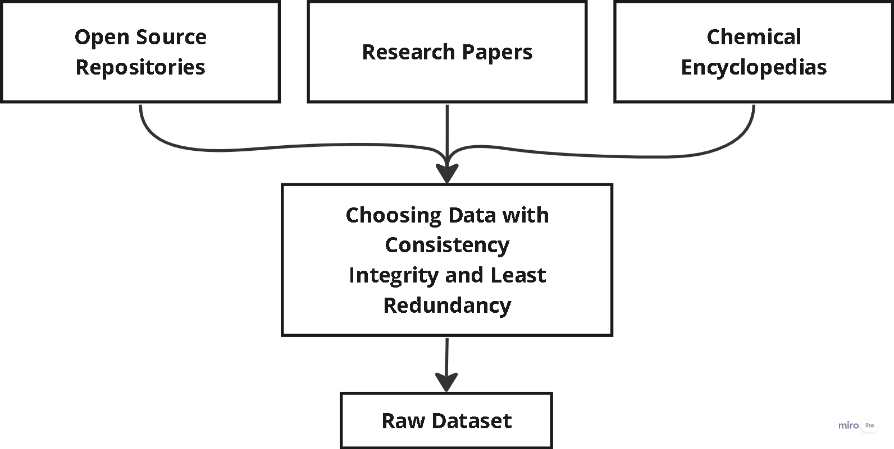

* **Preprocessing these Different Datasets into a Homographic Dataset**: Once the datasets are collected, the next step is preprocessing. This involves cleaning the data to remove any inconsistencies, errors, or missing values. Different datasets may have varying formats, units of measurement, and levels of granularity.

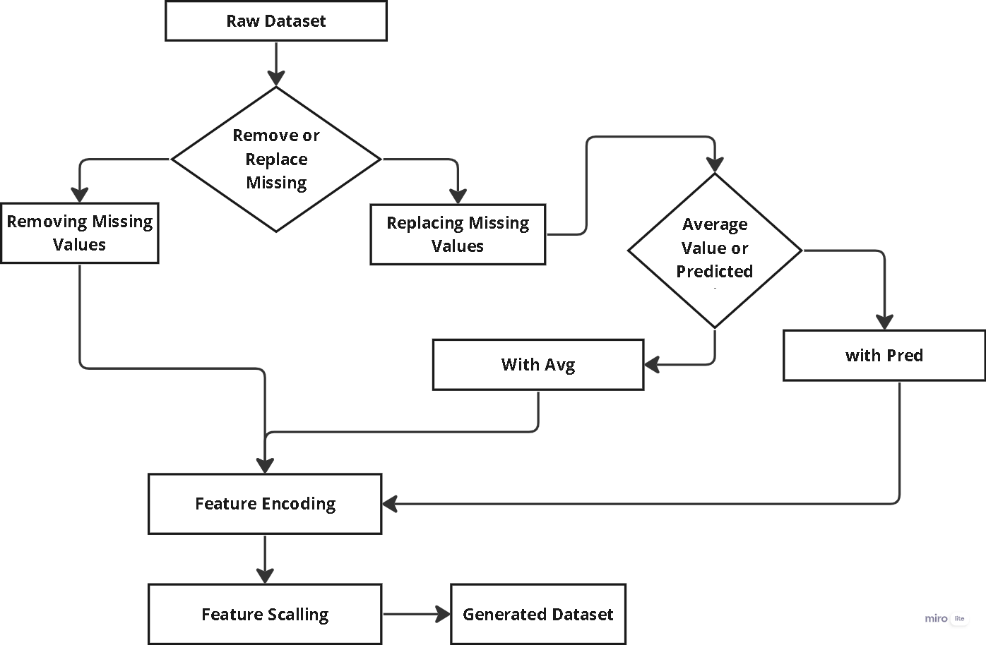

* **Applying Different ML & AI Models:** With a clean and standardized dataset, various ML and AI models can be applied to address the specific problem at hand. This could include supervised learning models like regression and classification, unsupervised learning models like clustering, or more complex models like neural networks and deep learning architectures. The choice of model depends on the nature of the problem, the type of data, and the specific objectives. For example, predictive maintenance might use regression models, while threat detection might use classification models. Implementing these models involves selecting appropriate algorithms, tuning hyperparameters, and training the models on the preprocessed dataset.

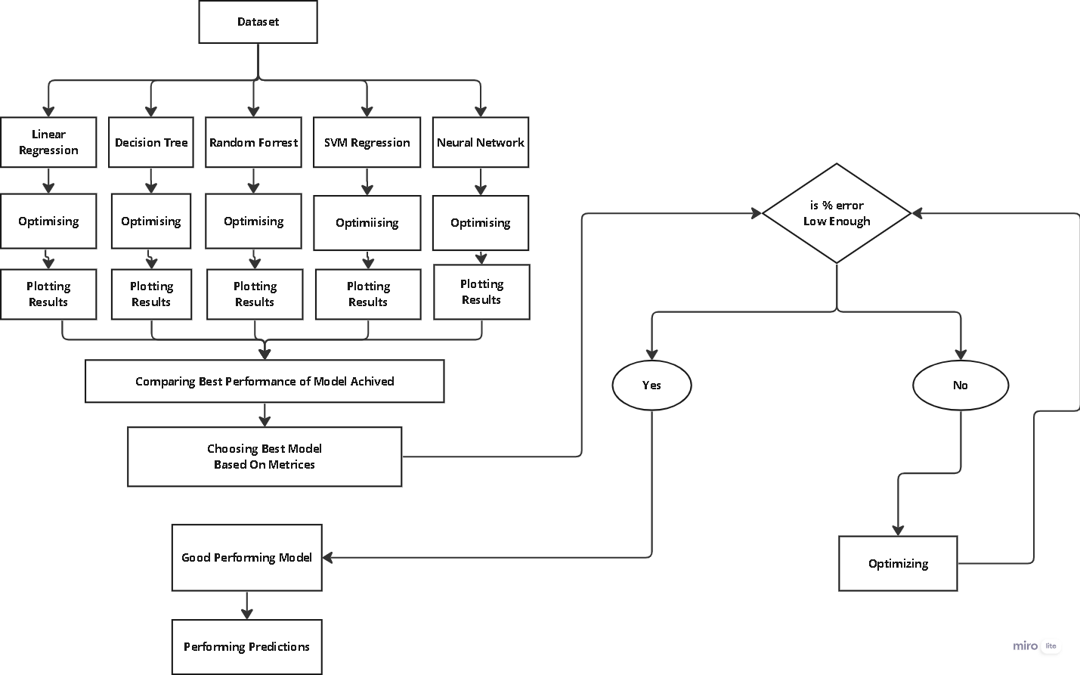

* **Comparing Performances to Get the Best Results:** After applying different models, their performances are compared to identify the best-performing model. This involves evaluating each model using appropriate metrics such as accuracy, precision, recall, F1 score, mean squared error (MSE), or area under the receiver operating characteristic curve (AUC-ROC). Cross-validation techniques and statistical tests can be used to ensure the robustness and reliability of the results. By comparing these performance metrics, the most effective model for the specific defense application can be selected. This step is critical for ensuring that the chosen model provides the best possible predictive power and operational utility.
* **Documenting the Whole Process**: Finally, documenting the entire process is essential for transparency, reproducibility, and future reference. This includes detailing the steps taken in acquiring domain knowledge, collecting and preprocessing data, applying and tuning models, and comparing their performances.

**2.2 Need of Domain Knowledge**

Domain knowledge complements machine learning techniques by providing context, expertise, and insights that enhance the entire machine learning lifecycle—from data understanding and feature engineering to model interpretation, validation, and business impact. It bridges the gap between data science and domain expertise, leading to more impactful and successful machine learning applications in diverse fields and industries.

Having domain knowledge is crucial for performing machine learning effectively in any field for several reasons:

1. **Data Understanding:** Domain knowledge helps in understanding the data better. It allows you to identify relevant features, understand data distributions, recognize outliers, and preprocess data appropriately. This understanding leads to better data quality and model performance.
2. **Feature Engineering:** Domain knowledge aids in feature engineering, where you create new features or transform existing ones to improve model performance. Understanding the relationships and dependencies in the data helps in generating meaningful features that capture the underlying patterns and trends.
3. **Model Interpretability:** Knowing the domain allows you to interpret the model results effectively. You can explain why certain predictions are made, understand the impact of different features on the predictions, and validate the model's decisions based on domain expertise.
4. **Problem Framing:** Domain knowledge helps in framing the machine learning problem correctly. You can define the problem statement, set realistic goals, determine relevant evaluation metrics, and design the machine learning pipeline in a way that aligns with the domain requirements and constraints.
5. **Data Collection and Labeling**: In many cases, domain knowledge is essential for collecting and labeling data. You may need to understand the context, semantics, and nuances of the data to ensure accurate labeling and annotation, especially in domains with specialized terminology or domain-specific concepts.
6. **Model Selection and Tuning:** Knowing the domain can guide you in selecting the appropriate machine learning algorithms, hyperparameters, and optimization techniques. It allows you to tune the models effectively, address domain-specific challenges, and optimize model performance for real-world applications.
7. **Validation and Evaluation:** Domain knowledge is valuable during model validation and evaluation. You can design meaningful validation strategies, interpret evaluation results in context, identify potential biases or limitations, and make informed decisions about model deployment based on domain insights.

**Chapter 3 : Prediction Models Used**

**3.1 Regression Models**

### 1. Support Vector Regressor (SVR)

**Working**: SVR uses the same principles as the Support Vector Machine (SVM) but for regression problems. It attempts to find a hyperplane in an N-dimensional space that fits the data points. SVR tries to fit the best line within a threshold value, often called epsilon. Data points within this threshold are ignored, and the algorithm focuses on the data points that lie outside this margin, which are called support vectors.

**Advantages**:

* Effective in high-dimensional spaces.
* Versatile as it can use different kernel functions (linear, polynomial, RBF).

**Disadvantages**:

* Can be inefficient with large datasets.
* The choice of kernel and parameters can significantly affect performance.

### 2. Light Gradient Boosting Machine (LightGBM)

**Working**: LightGBM is a gradient boosting framework that uses tree-based learning algorithms. It grows trees leaf-wise rather than level-wise, which makes it faster and more efficient.

**Advantages**:

* Extremely fast and efficient.
* Handles large-scale data and high-dimensional features well.
* Capable of handling categorical features directly.

**Disadvantages**:

* Can overfit on small datasets.
* Requires careful parameter tuning.

### 3. Ridge Regression

**Working**: Ridge regression is a type of linear regression that includes a regularization term (L2 regularization). This term penalizes the magnitude of the coefficients to reduce overfitting.

**Advantages**:

* Reduces overfitting by shrinking coefficients.
* Works well with multicollinearity.

**Disadvantages**:

* All coefficients are shrunk by the same factor, which might not be optimal in all cases.

### 4. Lasso Regression

**Working**: Lasso regression (Least Absolute Shrinkage and Selection Operator) is another type of linear regression that includes an L1 regularization term. This term can shrink some coefficients to zero, effectively performing feature selection.

**Advantages**:

* Can select important features by shrinking coefficients to zero.
* Helps in creating simpler, more interpretable models.

**Disadvantages**:

* Can discard useful features along with irrelevant ones.
* May not perform well with highly correlated features.

### 5. Elastic Net

**Working**: Elastic Net is a linear regression model that combines both L1 and L2 regularization terms. It aims to balance the benefits of both Ridge and Lasso regression.

**Advantages**:

* Handles multicollinearity by combining L1 and L2 penalties.
* Can perform feature selection and handle correlated features better than Lasso alone.

**Disadvantages**:

* Requires tuning of two hyperparameters (L1 and L2 penalties).
* More complex than Ridge or Lasso.

### 6. Linear Regression

**Working**: Linear regression attempts to model the relationship between the dependent variable and one or more independent variables by fitting a linear equation to the observed data.

**Advantages**:

* Simple to implement and interpret.
* Computationally efficient.

**Disadvantages**:

* Assumes a linear relationship, which may not hold in practice.
* Sensitive to outliers.

### 7. Random Forest Regressor

**Working**: Random Forest is an ensemble learning method that constructs multiple decision trees during training and outputs the mean prediction of the individual trees to improve accuracy and control overfitting.

**Advantages**:

* Can model complex relationships and handle high-dimensional data.
* Robust to overfitting and noise.

**Disadvantages**:

* Can be computationally intensive.
* Less interpretable compared to linear models.

### 8. Extreme Gradient Boosting (XGBoost)

**Working**: XGBoost is an optimized gradient boosting library designed to be highly efficient and flexible. It uses a tree ensemble model where new trees are added to correct the errors made by existing trees.

**Advantages**:

* Highly efficient and scalable.
* Often outperforms other algorithms in competitions.

**Disadvantages**:

* Requires careful tuning of parameters.
* Can overfit if not properly regularized.

### 9. Neural Network

**Working**: Neural networks consist of layers of interconnected nodes or neurons that can model complex nonlinear relationships. They are trained using backpropagation and gradient descent methods.

**Advantages**:

* Can model very complex relationships.
* Highly flexible and can be used for a variety of tasks.

**Disadvantages**:

* Requires a large amount of data and computational resources.
* Difficult to interpret and tune.

### 10. Kernel Ridge Regression (Laplacian Kernel)

**Working**: Kernel Ridge Regression is a combination of ridge regression and the kernel trick. The Laplacian kernel is used to map the data into a higher-dimensional space where it is easier to perform the linear regression.

**Advantages**:

* Can model non-linear relationships.
* Combines the advantages of Ridge Regression with the power of the kernel trick.

**Disadvantages**:

* Computationally intensive.
* Requires careful selection of the kernel and its parameters.

Each of these regression techniques has its own set of strengths and weaknesses, making them suitable for different types of datasets and problems. Choosing the right one often depends on the specific characteristics of the data and the problem at hand.

### 3.2 Classification Models

### 1. Decision Tree Classifier

**Working**: A Decision Tree Classifier splits the data into subsets based on the value of input features. This splitting is done recursively, creating a tree-like structure where each node represents a feature, each branch represents a decision rule, and each leaf node represents an outcome (class label).

**Advantages**:

* Simple to understand and interpret.
* Requires little data preprocessing (e.g., no need for normalization).
* Handles both numerical and categorical data.

**Disadvantages**:

* Prone to overfitting, especially with deep trees.
* Sensitive to small variations in the data (can produce different trees with different splits).

### 2. Random Forest Classifier

**Working**: A Random Forest Classifier is an ensemble of decision trees, typically trained with the "bagging" method. The algorithm creates multiple decision trees using randomly selected subsets of the data and features, then aggregates their predictions.

**Advantages**:

* Reduces overfitting compared to individual decision trees.
* Handles large datasets and high-dimensional data well.
* Provides feature importance measures.

**Disadvantages**:

* Can be computationally intensive with a large number of trees.
* Less interpretable than a single decision tree.

### 3. Support Vector Classifier (SVC)

**Working**: SVC is a classification method that finds the hyperplane which best separates the data into classes. It aims to maximize the margin between the closest points of the classes (support vectors).

**Advantages**:

* Effective in high-dimensional spaces.
* Versatile with the use of different kernel functions (linear, polynomial, RBF).

**Disadvantages**:

* Memory-intensive for large datasets.
* Requires careful parameter tuning and choice of the kernel.

### 4. Gradient Boosting Classifier

**Working**: Gradient Boosting Classifier builds an ensemble of trees sequentially. Each tree corrects the errors made by the previous trees. It uses gradient descent to minimize the loss function.

**Advantages**:

* High predictive accuracy.
* Can handle various types of data and loss functions.
* Good performance on imbalanced datasets.

**Disadvantages**:

* Computationally expensive and time-consuming.
* Sensitive to hyperparameters and prone to overfitting if not properly tuned.

### 5. CatBoost Classifier

**Working**: CatBoost is a gradient boosting algorithm that handles categorical features automatically and efficiently. It uses ordered boosting, which reduces the prediction shift and makes the model more robust.

**Advantages**:

* Handles categorical features without preprocessing.
* Efficient and scalable.
* Reduces overfitting with ordered boosting.

**Disadvantages**:

* Requires careful parameter tuning.
* Less interpretable than simpler models.

### 6. K Neighbors Classifier (KNN)

**Working**: KNN is a simple, instance-based learning algorithm. It classifies a data point based on the majority class of its k-nearest neighbors in the feature space.

**Advantages**:

* Simple and easy to implement.
* No training phase (instance-based learning).
* Works well with small datasets.

**Disadvantages**:

* Computationally intensive during prediction.
* Sensitive to the choice of k and distance metric.
* Does not handle large or high-dimensional datasets well.

### 7. AdaBoost Classifier

**Working**: AdaBoost combines multiple weak classifiers to form a strong classifier. It adjusts the weights of incorrectly classified instances, making subsequent classifiers focus more on difficult cases.

**Advantages**:

* Improves the accuracy of weak classifiers.
* Versatile and can be used with various base classifiers.

**Disadvantages**:

* Sensitive to noisy data and outliers.
* Can overfit if not properly regularized.

### 8. Logistic Regression

**Working**: Logistic Regression models the probability that an instance belongs to a particular class. It uses the logistic function to map predicted values to probabilities.

**Advantages**:

* Simple and easy to implement.
* Provides probabilities and interpretable coefficients.
* Works well with linearly separable data.

**Disadvantages**:

* Assumes a linear relationship between features and the log-odds of the outcome.
* May struggle with complex, non-linear relationships.

**Chapter 4 : Predicting the Performance of HEMs**

**4.1 Abstract**

Predicting the performance of High-Energy Materials (HEMs) is crucial for advancing technologies in defense, aerospace, and energy storage. HEMs, characterized by their high energy density and rapid energy release, play a pivotal role in applications requiring controlled explosions and propulsion. Traditional experimental methods for evaluating HEM performance are often time-consuming, costly, and pose significant safety risks.

Machine learning (ML) techniques offer a transformative approach to predict HEM performance by analyzing large datasets and identifying complex patterns that are not easily discernible through conventional methods. By leveraging ML algorithms, researchers can accelerate the design and optimization of HEMs, predict critical properties such as detonation velocity and heat of formation, and enhance safety protocols. This predictive capability enables more efficient and safer development cycles, reducing the reliance on extensive empirical testing.

The integration of ML with HEM research not only streamlines the discovery process but also opens avenues for innovative material design, ultimately contributing to the advancement of high-performance materials and systems. This abstract underscores the importance of predictive modeling in revolutionizing the study and application of HEMs, highlighting its potential to drive significant technological breakthroughs.

**4.2 HEMs**

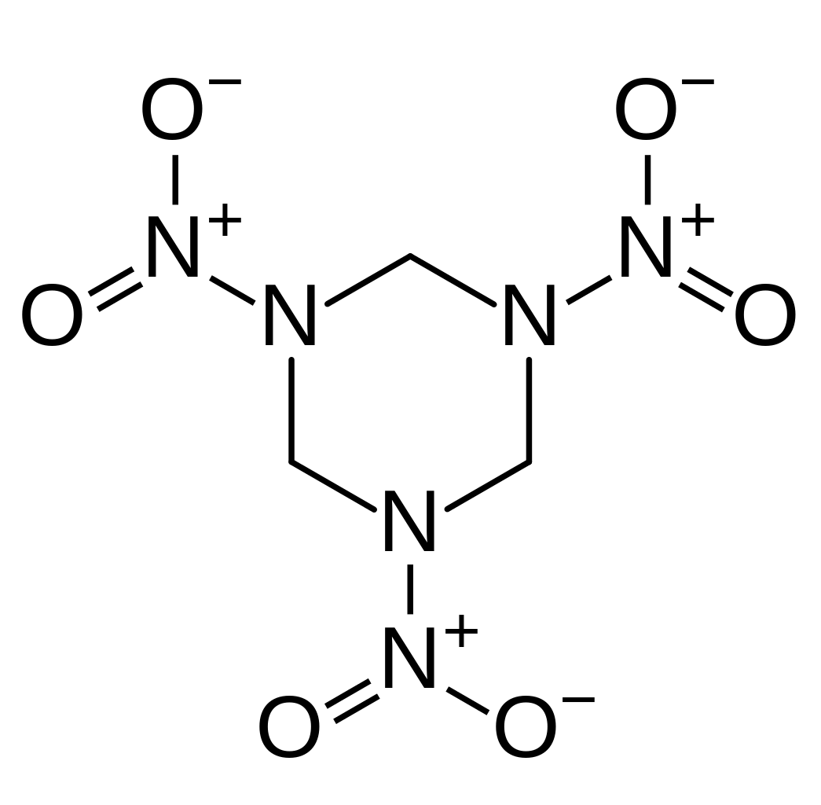

**Fig. Molecular Formula of RDX a very commonly used HEM.**

High-energy materials (HEMs) are substances capable of releasing a large amount of energy upon initiation or under specific conditions. These materials are used in various applications, including propulsion, explosives, pyrotechnics, and energetic devices. Here are the key characteristics and types of high-energy materials:

1. **Energy Release**: High-energy materials can release energy rapidly and in a controlled manner. This energy release can occur through chemical reactions, combustion, detonation, or deflagration processes.
2. **Chemical Composition:**

* **Explosives:** Explosives are a type of high-energy material designed to undergo rapid decomposition or combustion, producing large volumes of gas and heat. Examples include TNT (trinitrotoluene), RDX (cyclotrimethylenetrinitramine), HMX (cyclotetramethylenetetranitramine), PETN (pentaerythritol tetranitrate), and various composite explosives.
* **Propellants:** Propellants are used in rocket engines, firearms, and propulsion systems to generate thrust or propel projectiles. They typically consist of a fuel and an oxidizer, such as solid propellants (e.g., ammonium perchlorate-based) or liquid propellants (e.g., hydrazine-based).
* **Pyrotechnics:** Pyrotechnic materials produce light, heat, sound, or smoke through controlled combustion reactions. Examples include fireworks compositions, signaling flares, incendiary devices, and illumination flares.

Energetic Materials: Energetic materials encompass a wide range of substances with high energy content, including high explosives, propellants, pyrotechnics, and reactive materials used in defense, aerospace, mining, and industrial applications.

Applications:

1. **Defense and Military:** High-energy materials are crucial in military applications for manufacturing explosives, munitions, warheads, missiles, and rocket propellants. They play a vital role in enhancing firepower, mobility, and effectiveness of defense systems.
2. **Aerospace and Rocketry:** Propellants and energetic materials are used in aerospace engineering for rocket propulsion, satellite launches, spacecraft maneuvers, and orbital insertion. They provide the necessary thrust and velocity for space exploration and satellite deployments.
3. **Mining and Demolition:** Explosives are employed in mining operations for blasting rock, excavating ores, and shaping terrain. They are also used in demolition, construction, and civil engineering projects for controlled destruction and structural dismantling.
4. **Safety and Security:** High-energy materials are utilized in safety devices such as airbag inflators, fire suppression systems, and emergency signaling devices. They are also used in forensic investigations for detecting explosives residues and analyzing blast effects.
5. **Safety and Handling:** Due to their high energy content and potential hazards, high-energy materials require careful handling, storage, transportation, and disposal procedures. Safety protocols, protective equipment, and regulatory compliance are essential in dealing with these materials safely.

In summary, high-energy materials encompass a diverse range of substances designed to release energy rapidly for various applications, including defense, aerospace, mining, pyrotechnics, and safety devices. They play a critical role in modern technology, industry, and defense systems, but their handling and use require specialized knowledge, expertise, and safety precautions.

**4.3 Characteristics of High-Energy Materials:**

* **Energy Content:**

HEMs store a significant amount of chemical energy within their molecular structures, allowing for rapid release of energy during reactions.

This energy release can occur through exothermic reactions, combustion, detonation, or deflagration processes, depending on the specific type of material and its intended application.

* **Chemical Stability and Sensitivity:**

HEMs exhibit varying degrees of chemical stability and sensitivity to stimuli such as heat, shock, friction, and impact.

Some HEMs are highly stable under normal conditions but can undergo rapid decomposition or ignition under specific triggers, while others may be more sensitive and prone to spontaneous reactions.

* **Physical Forms:**

HEMs can exist in different physical forms, including solid, liquid, and gas phases, depending on their composition, formulation, and intended use.

Solid HEMs are commonly used in explosives, propellants, and pyrotechnics, while liquid and gaseous HEMs may be used in specialized applications such as rocket propulsion and energetic materials synthesis.

* **Energetic Materials:**

Energetic materials encompass a broad category of substances with high energy content, including explosives, propellants, pyrotechnics, and reactive materials used in various industrial, military, and scientific applications.

**4.4 Applications of High-Energy Materials:**

* **Defense and Military:** HEMs are critical in defense and military applications for manufacturing munitions, warheads, missiles, bombs, and rocket propellants.

They enhance the firepower, range, accuracy, and lethality of military systems and provide strategic advantages in combat scenarios.

* **Aerospace and Rocketry:** HEMs play a vital role in aerospace engineering for rocket propulsion, satellite launches, space exploration, and orbital maneuvers.

They enable spacecraft to achieve escape velocities, enter specific orbits, and conduct missions in space.

* **Mining and Demolition:** Explosives are used in mining operations for rock blasting, tunneling, quarrying, and excavation of minerals.

They are also employed in demolition, construction, and civil engineering projects for controlled demolition of structures, buildings, and infrastructure.

Regular inspections, audits, and safety assessments are conducted to ensure compliance and adherence to best practices in HEMs management.

**Types Of Explosives**

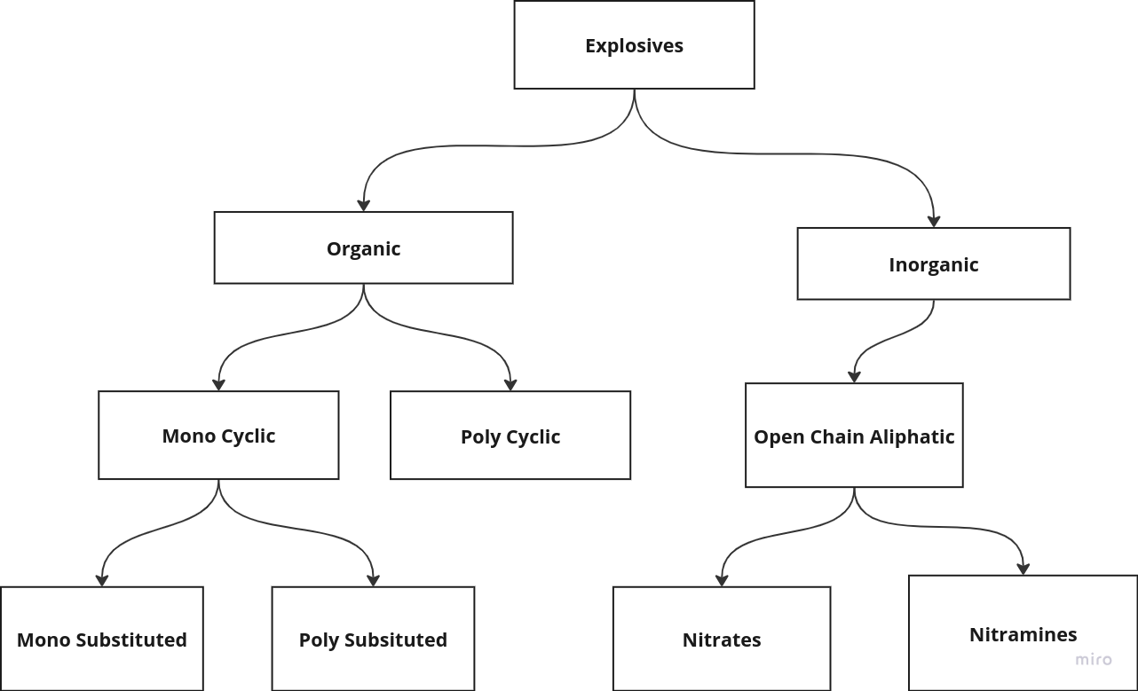

**Fig : Types of Different Explosives**

In conclusion, high-energy materials are diverse substances with significant energy content, utilized in defense, aerospace, mining, pyrotechnics, and safety applications. Understanding their characteristics, types, applications, and safety considerations is crucial for responsible handling, utilization, and management of these materials in various industries and sectors.

**4.5 Properties Of Interest**

There are specific properties of HEMs which are very important to evaluate the performance of explosives. These properties will be our central interests. These include:

**4.5.1 Friction Sensitivity**

Friction sensitivity refers to the propensity of a material to undergo an exothermic reaction, combustion, or detonation when subjected to frictional forces. This sensitivity is a critical characteristic of high-energy materials (HEMs) and is influenced by various factors, including composition, physical form, particle size, morphology, and surface properties. Here's a detailed explanation of friction sensitivity:

**4.5.1.1 Factors Influencing Friction Sensitivity:**

* **Chemical Composition:** The chemical composition of a material plays a significant role in its friction sensitivity. Certain chemical groups, functional moieties, or energetic components within the material may contribute to increased sensitivity to friction.

Materials containing nitro, nitrate, nitramine, or azide groups are often more friction-sensitive due to their energetic nature and susceptibility to mechanical activation.

* **Physical Form:** The physical form of a material, such as solid, liquid, or powder, can affect its friction sensitivity. Finely divided powders or particulate materials are generally more sensitive to friction than bulk solids or liquids.

The surface area-to-volume ratio increases with decreasing particle size, leading to enhanced reactivity and susceptibility to friction-induced ignition or initiation.

* **Particle Size and Morphology:** Smaller particle sizes and irregular morphologies (e.g., porous, rough surfaces) can increase friction sensitivity by promoting intimate contact between particles and enhancing mechanical energy transfer during frictional events.

Agglomerates, clusters, or aggregates of particles may exhibit localized hot spots or areas of increased reactivity, contributing to friction-induced reactions.

* **Impurities and Additives:** Presence of impurities, contaminants, or reactive additives in the material can influence friction sensitivity. Impurities may act as sensitizers or catalysts for friction-induced reactions, leading to lowered ignition thresholds.

Additives such as lubricants, binders, stabilizers, or inert fillers may modify friction sensitivity by altering the material's mechanical properties, surface characteristics, or chemical interactions.

**4.5.1.2 Mechanisms of Friction Sensitivity:**

* **Mechanical Energy Transfer:** Frictional forces applied to a material result in mechanical energy transfer, causing deformation, shearing, grinding, or impact on the material's surface.
* Mechanical energy can lead to localized heating, pressure buildup, microstructural changes, and activation of chemical reactions or decomposition pathways within the material.
* **Heat Generation:** Frictional contact generates heat due to frictional work, adiabatic heating, and deformation energy conversion.
* Elevated temperatures at friction interfaces can promote thermal decomposition, ignition, or thermal runaway reactions in friction-sensitive materials.
* **Chemical Activation:** Friction can induce chemical activation of reactive functional groups or energetic components within the material.

Molecular rearrangements, bond scission, radical formation, and energy release mechanisms may be triggered by mechanical stresses and friction-induced shear forces.

**4.5.1.3 Measurement and Assessment of Friction Sensitivity:**

* **Friction Tests:** Friction sensitivity is often evaluated through standardized friction tests, such as the BAM friction tester, ABL friction tester, or modified Bruceton method.

These tests involve controlled application of frictional forces to a sample material under specified conditions (e.g., load, speed, surface roughness) to determine the likelihood of ignition or reaction initiation.

* **Sensitivity Classifications:** Friction sensitivity data is typically used to classify materials into sensitivity categories, ranging from non-sensitive (insensitive to friction) to highly sensitive (prone to friction-induced reactions).

Classification criteria may include initiation threshold energy, ignition delay time, reaction severity, and hazard potential assessments.

**4.5.1.4 Safety Considerations and Risk Mitigation:**

* **Handling Precautions:** Friction-sensitive materials require careful handling, storage, transportation, and processing to minimize risks of accidental ignition or initiation.

Use of appropriate containers, packaging, and handling procedures is essential to prevent frictional stimuli and mechanical shocks.

* **Safety Testing:** Prior safety testing, risk assessments, and hazard analyses should be conducted to evaluate the friction sensitivity of materials and implement risk mitigation strategies.

Testing protocols may include sensitivity screening tests, compatibility studies, impact tests, and thermal stability assessments.

* **Regulatory Compliance:** Compliance with regulatory standards, safety guidelines, and best practices for handling friction-sensitive materials is necessary to ensure workplace safety, environmental protection, and risk management.

Training personnel in safe handling practices, emergency response protocols, and hazard mitigation procedures is critical for reducing the likelihood of accidents and incidents involving friction-sensitive materials.

In summary, friction sensitivity is a crucial characteristic of high-energy materials, influenced by composition, physical properties, particle size, and surface interactions. Understanding the mechanisms, measurement techniques, safety considerations, and risk mitigation strategies associated with friction sensitivity is essential for safe handling and utilization of these materials in various industrial, defense, and research applications.

**4.5.2 Impact Sensitivity**

Impact sensitivity refers to the propensity of a material to undergo an exothermic reaction, combustion, or detonation upon impact or mechanical shock. This sensitivity is a critical characteristic of high-energy materials (HEMs) and is influenced by various factors, including composition, physical form, particle size, morphology, and chemical reactivity. Here's a detailed explanation of impact sensitivity:

**4.5.2.1 Factors Influencing Impact Sensitivity:**

* **Chemical Composition:** The chemical composition of a material plays a significant role in its impact sensitivity. Certain chemical groups, functional moieties, or energetic components within the material may contribute to increased sensitivity to mechanical shock.

Materials containing nitro, nitrate, nitramine, or peroxide groups are often more impact-sensitive due to their energetic nature and susceptibility to mechanical activation.

* **Physical Form:** The physical form of a material, such as solid, liquid, or powder, can affect its impact sensitivity. Finely divided powders or particulate materials are generally more sensitive to impact than bulk solids or liquids.

The surface area-to-volume ratio increases with decreasing particle size, leading to enhanced reactivity and susceptibility to impact-induced initiation or detonation.

* **Particle Size and Morphology:** Smaller particle sizes and irregular morphologies (e.g., porous, rough surfaces) can increase impact sensitivity by promoting intimate contact between particles and enhancing energy transfer during impact events.

Sharp edges, cracks, defects, or voids in the material's structure may act as initiation sites or stress concentrators, leading to localized reactions upon impact.

* **Chemical Reactivity:** The intrinsic chemical reactivity of a material, including its decomposition pathways, reaction kinetics, and energy release mechanisms, influences impact sensitivity.

Materials with fast-reacting or highly exothermic decomposition processes are more likely to exhibit high impact sensitivity and rapid propagation of reactions upon mechanical shock.

**4.5.2.2 Mechanisms of Impact Sensitivity:**

* **Mechanical Shock:** Impact sensitivity is primarily driven by mechanical shock or impact energy transferred to the material during handling, processing, or transportation.

Rapid deformation, compression, shear forces, and stress waves generated by impact can lead to energy localization, hot spot formation, and initiation of chemical reactions within the material.

* **Frictional Heating:** Impact events can result in frictional heating at contact surfaces, leading to localized temperature spikes and thermal activation of reactive species or energetic components.

Friction-induced heating may enhance chemical reactivity, accelerate decomposition rates, and facilitate energy release in impact-sensitive materials.

* **High Strain Rates:** Impact loading induces high strain rates and deformation rates in materials, causing structural changes, phase transitions, and energy dissipation mechanisms.

High strain rates can promote mechanical instabilities, shock-induced transformations, and initiation of shock-sensitive reactions in materials.

**4.5.2.3 Measurement and Assessment of Impact Sensitivity:**

* **Impact Tests:** Impact sensitivity is evaluated through standardized impact tests, such as the BAM drop hammer test, Bruceton impact sensitivity test, and ball mill test.

These tests involve controlled application of impact energy to a sample material under specified conditions (e.g., drop height, impact velocity) to determine its likelihood of initiation or detonation.

* **Sensitivity Classifications:** Impact sensitivity data is used to classify materials into sensitivity categories, ranging from non-sensitive (insensitive to impact) to highly sensitive (prone to impact-induced reactions).

Classification criteria may include impact initiation threshold energy, reaction severity, fragment size, and hazard potential assessments.

**4.5.2.4 Safety Considerations and Risk Mitigation:**

* Prior safety testing, risk assessments, and hazard analyses should be conducted to evaluate the impact sensitivity of materials and implement risk mitigation strategies.

Testing protocols may include sensitivity screening tests, drop tests, impact tests, and compatibility studies to assess the material's response to mechanical shock.

* **Regulatory Compliance:**

Compliance with regulatory standards, safety guidelines, and best practices for handling impact-sensitive materials is necessary to ensure workplace safety, environmental protection, and risk management.

Training personnel in safe handling practices, impact mitigation techniques, and emergency response protocols is critical for reducing the likelihood of accidents and incidents involving impact-sensitive materials.

In summary, impact sensitivity is a critical characteristic of high-energy materials, influenced by composition, physical properties, particle size, and chemical reactivity. Understanding the mechanisms, measurement techniques, safety considerations, and risk mitigation strategies associated with impact sensitivity is essential for safe handling and utilization of these materials in various industrial, defense, and research applications.

**4.5.3 Detonation Velocity**

Detonation velocity refers to the speed at which a detonation wave propagates through a high-explosive material. This velocity is a critical parameter that characterizes the performance and behavior of explosives and is influenced by various factors, including chemical composition, physical properties, confinement conditions, and initiation methods. Here's a detailed explanation of detonation velocity:

**4.5.3.1 Factors Influencing Detonation Velocity:**

* **Chemical Composition:**The chemical composition of an explosive material plays a significant role in determining detonation velocity. Materials with high energy content, such as nitro compounds (e.g., TNT, RDX, HMX), tend to exhibit higher detonation velocities.

The presence of oxygen-rich groups (e.g., nitrate, nitroso, perchlorate) and high nitrogen content contributes to faster energy release and propagation of detonation waves.

* **Energy Density:** The energy density of an explosive, which is the amount of energy released per unit volume or mass, directly impacts detonation velocity. Higher energy density explosives typically have faster detonation velocities.

Energy density is influenced by the chemical structure, molecular weight, bond strength, and stoichiometry of the explosive composition.

* **Confinement and Density:** Confinement conditions, such as the presence of a surrounding medium (e.g., air, water, soil) or confinement in a container or casing, can affect detonation velocity.

Confinement increases the pressure on the explosive material, leading to enhanced energy release and faster propagation of the detonation wave. Higher material densities also contribute to faster velocities.

* **Initiation and Shockwave Characteristics:** The method of initiation, such as shock initiation, spark initiation, or pressure initiation, influences the characteristics of the detonation wave and its velocity.

Shockwave parameters, including pressure amplitude, duration, rise time, and waveform shape, impact the initiation and propagation of detonation waves in the explosive material.

* **Temperature and Pressure:** Temperature and pressure conditions during detonation affect detonation velocity. Higher temperatures and pressures typically result in faster detonation velocities due to increased energy release and more favorable reaction kinetics.

The detonation velocity may vary with temperature and pressure, following complex thermodynamic and kinetic relationships.

**4.5.3.2 Detonation Velocity Measurement:**

* **Experimental Methods:** Detonation velocity is measured experimentally using specialized equipment and techniques. Common methods include the use of detonation velocity gauges (DVGs), high-speed cameras, pressure sensors, and velocity interferometers.

Detonation velocity measurements are conducted under controlled conditions, varying parameters such as explosive mass, confinement geometry, initiation energy, and ambient conditions.

* **Detonation Tests:** Detonation tests, such as cylinder tests, plate dent tests, and gap tests, are performed to determine the detonation velocity of explosive materials.
* These tests involve initiating the explosive sample and measuring the time taken for the detonation wave to traverse a known distance, allowing for calculation of detonation velocity.

**4.5.3.3 Importance of Detonation Velocity:**

* **Performance Evaluation:** Detonation velocity is a key parameter used to evaluate the performance, efficiency, and effectiveness of explosive materials. Higher detonation velocities indicate greater energy release and more rapid propagation of explosive effects.

It is used in comparative studies to assess the relative performance of different explosives, formulations, and compositions.

* **Safety and Stability:** Knowledge of detonation velocity is essential for assessing the safety, stability, and handling characteristics of explosive materials.

Understanding detonation velocities helps in designing safe storage, transportation, and handling procedures, as well as predicting the potential hazards and risks associated with explosive use.

* **Engineering Design:** Detonation velocity data is used in engineering design and analysis of explosive devices, munitions, warheads, propellants, and pyrotechnic systems.

It informs the design parameters, blast effects calculations, shockwave propagation models, and performance predictions in defense, aerospace, mining, and industrial applications.

* **Research and Development:** In research and development of new explosive formulations, materials, and technologies, detonation velocity serves as a critical performance metric.

It guides the optimization, synthesis, testing, and validation of novel explosives with desired detonation characteristics for specific applications.

**4.5.3.4 Variations and Limitations:**

* **Detonation Front Structure:** Detonation velocity may vary within the explosive material due to factors such as detonation front curvature, wave shape, reaction zone thickness, and energy release mechanisms.

Complex detonation front structures, including multiple waves or rarefaction zones, can affect the observed detonation velocity and its interpretation.

* **Environmental Factors:** Environmental conditions, such as ambient temperature, humidity, altitude, and atmospheric pressure, can influence detonation velocity measurements and performance.

These factors may require corrections or adjustments to ensure accurate and consistent detonation velocity data under different operating conditions.

In summary, detonation velocity is a critical parameter that characterizes the performance, behavior, and safety considerations of explosive materials. Understanding the factors influencing detonation velocity, measurement techniques, applications, and limitations is essential for designing, testing, and utilizing explosives effectively in various fields, including defense, aerospace, mining, and industrial sectors.

**4.5.4 Heat of Formation**

The heat of formation, also known as the standard enthalpy of formation (ΔH°f), is the enthalpy change that occurs when one mole of a compound is formed from its constituent elements in their standard states at a specified temperature and pressure. It is a fundamental thermodynamic property used to quantify the energy released or absorbed during a chemical reaction that forms a compound.

Here's a detailed explanation of the heat of formation:

**4.5.4.1 Key Concepts:**

* **Enthalpy (H):** Enthalpy is a thermodynamic property that represents the total heat content of a system. It includes the internal energy of the system plus the product of pressure and volume.

Enthalpy changes (ΔH) are associated with energy exchanges during chemical reactions, phase transitions, and physical transformations.

* **Standard States:** Standard states refer to the defined conditions under which enthalpy values are measured and compared. For gases, the standard state is usually 1 bar pressure, while for solids and liquids, it's typically the pure substance at a specified temperature.
* **Heat of Formation:**

The heat of formation (ΔH°f) is the enthalpy change when one mole of a compound is formed from its constituent elements in their standard states.

The elements must be in their most stable forms at the specified temperature and pressure. For example, oxygen is diatomic (O2) in its standard state.

**4.5.4.2 Calculation of Heat of Formation:**

* **Reaction Representation:** The heat of formation is calculated based on the reaction that forms the compound from its elements. The reaction is typically written in the form:

**A + B + ... → Compound**

Where A, B, etc., represent the elements in their standard states.

* **Hess's Law:** Hess's Law states that the total enthalpy change of a reaction is independent of the pathway taken. This principle is applied to calculate the heat of formation.

If the heat of formation for each element is known, the heat of formation for the compound can be calculated using:

**ΔH°f(Compound) = Σ(ΔH°f(products)) - Σ(ΔH°f(reactants))**

Where Σ represents the summation over all products and reactants in the reaction.

* **Reference Tables:** Heat of formation values for common compounds and elements are available in thermodynamic tables and databases. These values are determined experimentally or calculated using theoretical methods.

Values are often given in units of kilojoules per mole (kJ/mol) or kilocalories per mole (kcal/mol).

**4.5.4.3 Significance and Applications:**

* **Energy Release/Absorption:** Positive ΔH°f values indicate that energy is absorbed during the formation of the compound, while negative values indicate energy release.

Heat of formation values provide insights into the energy changes associated with chemical reactions, including exothermic (energy-releasing) and endothermic (energy-absorbing) processes.

* **Thermochemical Calculations:** Heat of formation values are used in thermochemical calculations to determine reaction enthalpies, heat of reaction, heat of combustion, and heat of formation for complex reactions and systems.

These calculations are crucial in chemical engineering, combustion analysis, material synthesis, and energy conversion processes.

* **Standardization:** Heat of formation values are used to standardize enthalpy data and establish reference points for comparing the energy content of different compounds and reactions.

Standard enthalpy of formation values are tabulated for a wide range of substances and are essential in thermodynamics, kinetics, and materials science.

* **Chemical Stability:** The magnitude of the heat of formation can provide insights into the stability of compounds. Lower heat of formation values often indicate greater stability, while higher values may suggest higher reactivity or instability.

In summary, the heat of formation is a fundamental thermodynamic property that quantifies the energy changes associated with the formation of compounds from their constituent elements. It plays a vital role in energy calculations, reaction analysis, standardization of enthalpy data, and understanding the chemical stability and reactivity of substances.

**4.5.5 Detonation Pressure**

The detonation pressure of an explosive refers to the pressure generated by the detonation wave as it propagates through the explosive material. It is a critical parameter that characterizes the explosive's performance, energy release, and blast effects. The detonation pressure depends on various factors, including the chemical composition of the explosive, the energy content, the rate of energy release, and the confinement conditions. Here's a detailed explanation of detonation pressure:

**4.5.5.1 Key Concepts:**

* **Detonation Wave:** A detonation wave is a supersonic shockwave that travels through an explosive material at a speed faster than the speed of sound in that material. It is initiated by a high-energy source, such as a detonator or initiator.
* **Shock Front:** The detonation wave creates a shock front that compresses and heats the explosive material rapidly. This leads to rapid energy release and the generation of high pressures and temperatures.
* **Detonation Pressure:** Detonation pressure refers to the peak pressure achieved by the detonation wave as it travels through the explosive material. It is measured in units of pressure, such as pounds per square inch (psi) or megapascals (MPa).

**4.5.5.2 Measurement and Prediction:**

* **Experimental Measurement:** Detonation pressure is measured experimentally using specialized equipment, such as pressure transducers, gauges, or high-speed cameras.

Detonation tests, such as cylinder tests, plate dent tests, or confined blast tests, are conducted to determine the peak pressure and pressure-time profiles during detonation.

* **Theoretical Modeling:** The detonation pressure can be predicted using theoretical models and computational simulations based on the explosive's chemical kinetics, thermodynamics, and shockwave physics.

Models such as the Chapman-Jouguet (CJ) theory, Jones-Wilkins-Lee (JWL) equation of state, and hydrocode simulations are used to predict detonation pressures under different conditions.

**4.5.5.3 Significance and Applications:**

* **Explosive Performance:** Detonation pressure is a key indicator of explosive performance, energy content, and effectiveness in generating blast effects. Higher detonation pressures are often associated with more powerful explosive performance.

It is used in comparative studies to assess the relative performance of different explosives, formulations, and compositions.

* **Blast Effects:** The detonation pressure influences the magnitude and characteristics of blast effects, including shockwave intensity, blast wave propagation, fragmentation, cratering, and structural damage.

Understanding detonation pressures is crucial in designing explosive devices, munitions, warheads, propellants, and pyrotechnic systems for specific blast effects requirements.

* **Engineering Design:** Detonation pressure data is used in engineering design and analysis of explosive devices, blast-resistant structures, protective barriers, and safety systems.

Shock sensitivity refers to the propensity of a material to undergo a rapid and violent reaction when subjected to a sudden mechanical shock or impact. This sensitivity is a critical characteristic of high-energy materials (HEMs) and is influenced by various factors, including chemical composition, physical form, particle size, morphology, and energy content. Here's a detailed explanation of shock sensitivity:

**4.5.5.4 Factors Influencing Shock Sensitivity:**

* **Chemical Composition:** The chemical composition of a material plays a significant role in its shock sensitivity. Certain chemical groups, functional moieties, or energetic components within the material may contribute to increased sensitivity to mechanical shock.

Materials containing nitro, nitrate, nitramine, or peroxide groups are often more shock-sensitive due to their energetic nature and susceptibility to rapid energy release.

* **Energy Content:** The energy content of a material, which is related to its heat of formation, enthalpy, and combustion energy, influences shock sensitivity. Higher energy content materials tend to be more sensitive to shock due to the potential for rapid energy release.

Compounds with high energy density, such as high explosives, are particularly prone to shock-induced reactions.

* **Physical Form:** The physical form of a material, including its state (solid, liquid, powder) and particle size, can affect shock sensitivity. Finely divided powders or particulate materials are generally more sensitive to shock than bulk solids or liquids.

Smaller particle sizes increase the surface area-to-volume ratio, leading to enhanced reactivity and energy release upon shock impact.

* **Particle Morphology:** The morphology of particles, such as shape, surface roughness, porosity, and crystallinity, can influence shock sensitivity. Irregular or rough surfaces may act as initiation sites for rapid energy release upon shock loading.

Porous structures or agglomerates within the material can create localized hot spots or areas of increased reactivity under shock conditions.

* **Confinement and Containment:** Confinement conditions, such as the presence of a surrounding medium (e.g., air, water, soil) or confinement in a container or casing, can affect shock sensitivity.

Confinement may increase the pressure and energy transfer during shock events, leading to more intense reactions and higher sensitivity.

**4.5.5.5 Mechanisms of Shock Sensitivity:**

* **Mechanical Energy Transfer:** Shock sensitivity is primarily driven by the rapid transfer of mechanical energy to the material during impact or shock events.

Sudden deformation, compression, shear forces, and stress waves generated by shock loading can lead to rapid energy release, phase transitions, and initiation of chemical reactions or decomposition pathways within the material.

* **Energy Release and Activation:** Shock-induced deformation or stress can activate chemical bonds, functional groups, or energetic components within the material.

This activation leads to rapid energy release, exothermic reactions, bond scission, and generation of hot spots or reaction centers, contributing to shock-induced reactions.

* **Phase Transitions:** Shock loading can induce phase transitions, structural changes, or solid-state transformations in materials, affecting their mechanical properties, reactivity, and sensitivity.

Phase transitions may involve changes in crystal lattice structures, polymorphic transitions, or amorphization, which influence shock response and energy dissipation mechanisms.

* **Measurement and Assessment of Shock Sensitivity:** Shock Tests: Shock sensitivity is evaluated through specialized shock tests, such as the BAM impact sensitivity test, drop hammer tests, or plate dent tests.

These tests involve controlled application of mechanical shock or impact to a sample material under specified conditions (e.g., impact velocity, mass, geometry) to determine its likelihood of reaction, ignition, or decomposition.

* **Sensitivity Classifications:** Shock sensitivity data is used to classify materials into sensitivity categories, ranging from non-sensitive (insensitive to shock) to highly sensitive (prone to shock-induced reactions).

Classification criteria may include initiation threshold energy, impact pressure, reaction severity, and hazard potential assessments.

It informs the design parameters, blast effects calculations, shockwave propagation models, and structural integrity assessments in defense, mining, demolition, and industrial applications.

**4.6 Composing Datasets**

**Attributes Of Dataset:**

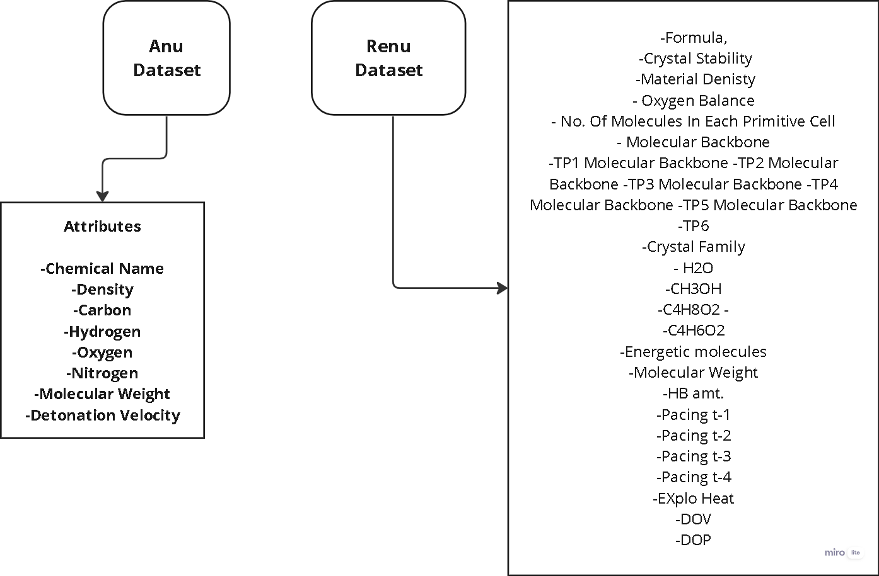

* **Name of Energetic Material :** The attribute "Name of Energetic Material" in refers to a specific field or column that contains information about the names of substances classified as energetic materials. Energetic materials are substances that release energy when subjected to certain stimuli, such as heat, shock, or impact. These materials are often used in various applications, including explosives, propellants, and pyrotechnics.
* **Molar Mass (g/mol):** It refers to the molar mass of a substance, expressed in grams per mole (g/mol). Molar mass is a physical property of a chemical element or compound and represents the mass of one mole of that substance. It is commonly used in chemistry and is essential for various calculations in the field.
* **Shock Sensitivity:** Shock sensitivity refers to how an explosive material responds to sudden mechanical shocks or impacts.

Explosive materials are sensitive to external stimuli, and shock sensitivity measures their susceptibility to detonation when subjected to sudden mechanical forces, such as impacts or shocks. Highly shock-sensitive explosives can detonate more easily under impact, posing greater safety risks during handling, transportation, or storage.

* **Friction Sensitivity:** Friction sensitivity refers to how an explosive material responds to frictional forces.

Friction sensitivity measures the likelihood of an explosive material detonating when subjected to frictional forces, such as rubbing or abrasion. Materials with high friction sensitivity may be more prone to accidental detonation if they experience friction during handling or other processes. Understanding friction sensitivity is crucial for ensuring the safe manufacturing, storage, and handling of explosive materials.

* **Carbon:** It is a chemical element with the symbol C and atomic number 6. It is a non-metal that is the fourth most abundant element in the universe by mass. Carbon is a key building block of life, forming the basis for organic chemistry and the structures of all known living organisms.
* **Hydrogen :** It is a chemical element with the symbol H and atomic number 1. It is the lightest and most abundant element in the universe, constituting about 75% of its elemental mass.
* **Oxygen :** It can play a crucial role in explosives by acting as an oxidizer. In explosive reactions, there is a rapid release of energy, often in the form of heat, light, sound, and the production of gases. Oxygen, as an oxidizer, supports the combustion of the explosive material, contributing to the overall reaction.
* **Nitrogen** : It plays a significant role in explosives, often serving as a key component in various explosive compounds. Nitrogen-containing compounds are commonly used in explosives due to their ability to release a large amount of energy during combustion or detonation.

Nitrogen is frequently incorporated into explosives in the form of nitro groups (-NO2). Nitro groups contain oxygen, and during the explosive reaction, they release energy by breaking the nitrogen-oxygen bonds and forming more stable nitrogen and oxygen gas molecules.

Examples of explosives with nitro groups include nitroglycerin (glyceryl trinitrate) and trinitrotoluene (TNT). Nitroglycerin, in particular, is highly sensitive and is often used as a primary explosive or as a component in dynamite.

* **Chemical Family : ("aromatic," "aliphatic," "inorganic")**

The terms "aromatic," "aliphatic," and "inorganic" are used to classify chemical compounds based on their structural characteristics and composition. Here's a brief explanation of each chemical family:

**1.) Aromatic Compounds:** Aromatic compounds are a type of hydrocarbon that contains a cyclic structure with alternating single and double bonds. The most common example is benzene (C6H6).

**2.) Aliphatic Compounds:** Aliphatic compounds are hydrocarbons that do not contain an aromatic ring. They can be either saturated (alkanes) or unsaturated (alkenes and alkynes) and may have linear or branched structures.

**3.) Inorganic Compounds:** Inorganic compounds are compounds that do not contain carbon-hydrogen (C-H) bonds. While this definition is broad, it generally includes minerals, salts, metals, and other compounds that are not classified as organic.

Structural Feature: Inorganic compounds can have diverse structures and compositions, including ionic compounds, covalent compounds, and metallic compounds.

**Example:** Sodium chloride (NaCl), water (H2O), sulfuric acid (H2SO4), ammonia (NH3).

* **Test Density :** Density is a fundamental property of matter and is often used to identify substances or materials. Objects with different densities will occupy different amounts of space for the same mass. For example, a material with a higher density will have more mass concentrated in a given volume compared to a material with lower density.
* **Detonation Velocity :** Detonation velocity refers to the speed at which a detonation wave travels through an explosive material under specific conditions. It represents the rate at which the chemical reaction associated with the detonation process progresses within the explosive substance.

**4.7 Predictions**

**Problem 1:** Prediction of y1 variable from Specialized Dataset 1

**Dataset :** “DRDO Specialized Dataset 1”

Test Train Split : 40 - 60

Input Parameters : x1, x2, x3, x4, x5

Predicting : y1

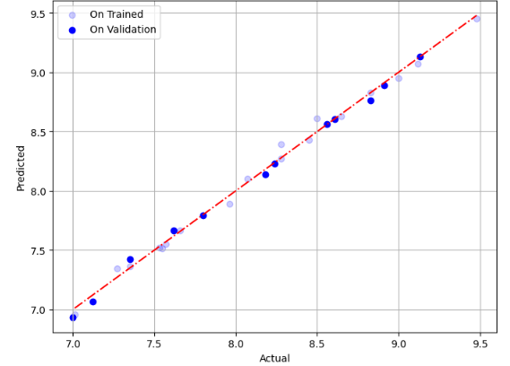

**Fig:** Linear Regression on Y1 in DRDOs Specialized Dataset 1

| **Model Used** | **Mean**  **Sq. Error** | **Mean**  **Abs. Er.** | **R2 Score** | **Hyper**  **Parameters** |
| --- | --- | --- | --- | --- |
| **Linear**  **Regression** | 0.0017 | 0.032 | 0.99 | Default |
| **Random**  **Forrest** | 0.18 | 0.38 | 0.61 | n_estimators = 500 |
| Polynomial Regression | 0.0003 | 0.01 | 0.99 | degree = 2 |

**Problem 2:** Prediction of y2 variable from DRDOs Specialized Dataset 1

**Dataset :** “DRDO Specialized Dataset 1”

Test Train Split : 40 - 60

Input Parameters : x1, x2, x3, x4, x5

Predicting : y2

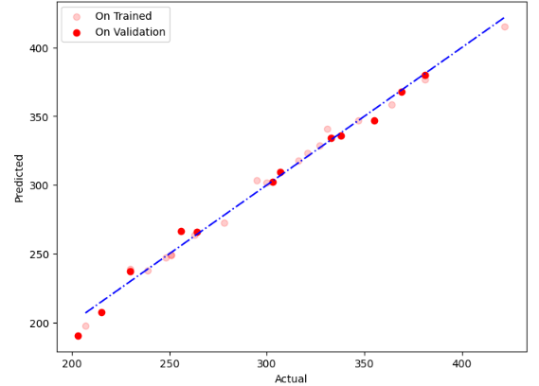

**Fig:** Polynomial Regression on Y1 in DRDOs Specialized Dataset 1

(degree = 2)

| **Model**  **Used** | **Mean**  **Sq. Er** | **Mean**  **Abs. Er.** | **R2 Score** | **Hyper Parameters** |
| --- | --- | --- | --- | --- |
| **Linear**  **Regression** | 38.13 | 4.67 | 0.98 | Default |
| **Random**  **Forrest** | 1134.55 | 31.1 | 0.67 | n_estimators = 200 |
| Polynomial Regression | 20.1 | 3.80 | 0.99 | degree = 2 |
| Kernel Ridge | 3642.41 | 54.38 | -0.05 | alpha=0.01,  kernel='laplacian',  gamma=0 |
| Ridge | 3198.02 | 51.83 | 0.075 | alpha=0.1, |
| LassoRegression | 235.0 | 11.25 | 0.93 | alpha=1 |

**Problem 3:** Prediction of y3 variable.

**Dataset :** “DRDO Specialized Dataset 2”

Test Train Split : 40 - 60 ( Except Random Forest where split is 20 - 80 )

Input Parameters : x1, x2, x3, x4, x5, x6, x7

Predicting : y1

Due to high interdependence of about 0.98 one of the variable x6 and x7 has to be

removed. In this experiment we have removed the variable x6.

| **Model Used** | **Mean Sq. Er** | **Mean Abs. Er.** | **R2 Score** |
| --- | --- | --- | --- |
| **Linear Regression** | 3511.0 | 47.76 | 0.092 |
| **Random Forest**  **( Split 20 – 80 )** | 1257.37 | 31.96 | 0.61 |
| **SVR** | 2765.20 | 39.57 | -0.09 |
| Kernel Ridge | 2041.0 | 41.27 | 0.47 |
| Ridge | 3213.05 | 47.367 | 0.169 |
| Lasso Regression | 3377.9 | 48.50 | 0.127 |
| Elastic Net Reg. | 2576.21 | 43.72 | 0.334 |

**Problem 4 : Predicting the Detonation Velocity of HEMs**

Dataset : “Anu Dataset”

Test Train Split : 30 - 70

Scaling : Standard Scaler

| **Model**  **Name** | **Mean**  **Squared**  **Error** | **Mean**  **Absolute**  **Error** | **R² Score** | **Hyperparameters** |
| --- | --- | --- | --- | --- |
| **Linear**  **Regression** | 0.122 | 0.260 | 0.770 | Default |
| **Decision**  **Tree** | 0.405 | 0.452 | 0.237 | Default |
| **Random**  **Forest** | 0.322 | 0.42 | 0.392 | n_estimators=100  , random_state=42 |
| **Support**  **Vector**  **Regression**  **(SVR)** | 0.1770 | 0.290 | 0.666 | C=best_C_value,  epsilon=best_epsilon  , gamma=best_gamma |
| **Ridge**  **Regression** | 0.0875 | 0.2148 | 0.835 | alpha=1.0 |
| **Kernel**  **Ridge**  **Regression** | 50.72 | 6.904 | -94.470 | | alpha=0.01,  kernel='laplacian',  gamma=0 | | --- | |
| **AdaBoost** | 0.356 | 0.45 | 0.328 | n_estimators=100  , learning_rate=0.7  , random_state=42 |
| **XGBoost** | 0.294 | 0.406 | 0.445 | objective='reg’  , eval_metric=['mae',  'rmse']  , max_depth=3,  eta=0.1  , subsample=0.8,  colsample_bytree=0.8  , seed=42 |

**Problem 5 : Predicting the Detonation Pressure of HEMs**

Dataset : “Renu Dataset”

Test Train Split : 30 - 70

Random State : 42

Max Depth : 9

Encoding Categorical Variable “Crystal Family”

Scaling : Standard Scaler

dataset.fillna('0', inplace=True)

dataset.replace('√','1', inplace= True)

| **Model**  **Name** | **Mean**  **Squared**  **Error** | **Mean**  **Absolute**  **Error** | **R² Score** | **Hyperparameters** |
| --- | --- | --- | --- | --- |
| **Linear**  **Regression** | 18.596 | 2.177 | 0.59 | Default |
| **Decision**  **Tree** | 18.202 | 2.539 | 0.59 | Default |
| **Random**  **Forest** | 11.435 | 2.007 | 0.74 | n_estimators=149,  random_state=42,  max_depth=9 |
| **SVM**  **Regressor** | 22.831 | 2.7039 | 0.49 | kernel='linear' |
| **Neural**  **Network** | 37.786 | 3.1974 | 0.166 | tf.keras.layers.Dense(128,  activation='relu',  input_shape=(X_train_scaled.s  hape[1],)),  tf.keras.layers.Dense(64,  activation='relu'),  tf.keras.layers.Dense(32,  activation='relu'),  tf.keras.layers.Dense(1)  ] |
| **MLP** | 33.196 | 2.93 | 0.26 | keras.Sequential([  keras.layers.Dense(128,  activation='relu',  input_shape=(X_train_scaled.s  hape[1],)),  keras.layers.Dense(64,  activation='relu'),  keras.layers.Dense(1)  ]) |

**Problem 6 : Predicting the Heat of Formation of HEMs**

Dataset : “Renu Dataset”

Test Train Split : 30 - 70

Random State : 42

Max Depth : 9

Encoding Categorical Variable “Crystal Family”

Scaling : Standard Scaler

dataset.fillna('0', inplace=True)

dataset.replace('√','1', inplace= True)

| **Model Name** | **Mean Squared Error** | **Mean Absolute Error** | **R² Score** | **Hyperparameters** |
| --- | --- | --- | --- | --- |
| **Linear Regression** | 61916.96 | 143.60 | 0.029 | Default |
| **Random Forest** | 43425.78 | 114.82 | 0.319 | n_estimators=149, random_state=42, max_depth=9 |
| **Decision Tree** | 77817.61 | 167.71 | -0.220 | alpha=0.45, kernel='linear', gamma=0.7 |
| **AdaBoost** | 50754.52 | 137.29 | 0.204 | n_estimators=50,learning_rate=1.0 |
| **Ridge Regression** | 48910.94 | 139.687 | 0.233 | learning_rate=1.0 |

**4.8 Feature Importance**

* **For Prediction of Detonation Velocity : On “Anu Dataset”**

Dataset : “Anu Dataset”

Test Train Split : 30 - 70

Model Random Forest

N_Estimators : 200

Random State : 42

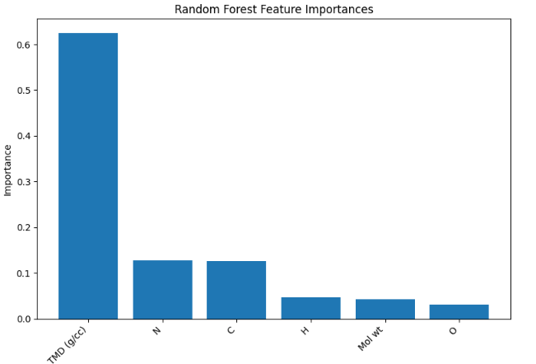

* **For Prediction of Heat of Formation: On “Renu Dataset”**

Dataset : “Renu Dataset”

Test Train Split : 30 - 70

Model Random Forest

N_Estimators : 149

Random State : 42

Max Depth : 9

Encoding Categorical Variable “Crystal Family”

dataset.fillna('0', inplace=True)

dataset.replace('√','1', inplace= True)

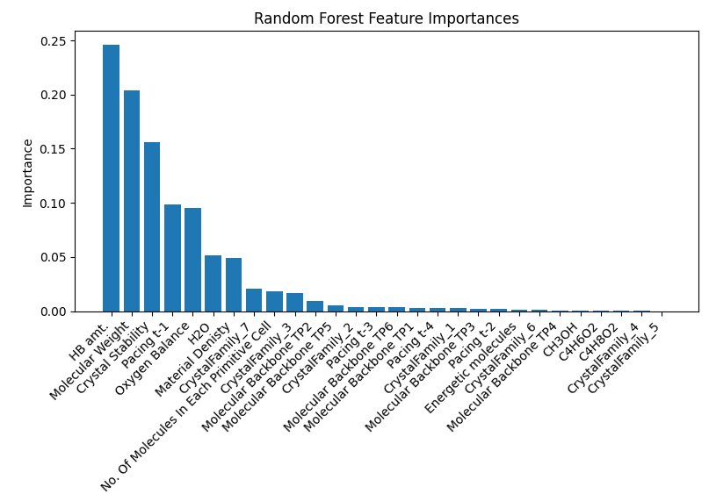

* **For Prediction of Detonation Pressure :**

Dataset : “Renu Dataset”

Encoding Categorical Variable “Crystal Family”

Test Train Split : 30 - 70

Model Random Forest

N_Estimators : 149

Random State : 42

Max Depth : 9

dataset.fillna('0', inplace=True)

dataset.replace('√','1', inplace= True)

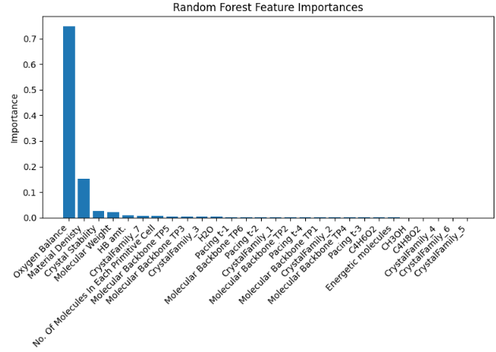

**Chapter 5 Predictions On the Projectiles Dataset**

**5.1 Abstract**

Predicting the behavior of projectiles is essential for enhancing the performance and safety of defense and aerospace systems. The study of projectiles involves understanding how various factors—such as shape, mass, material properties, impact velocity, and target characteristics—affect their performance during and after impact. Traditional experimental approaches to studying projectile dynamics are often expensive, time-consuming, and logistically challenging.

The application of machine learning (ML) techniques to projectile datasets offers a powerful alternative for predicting projectile behavior under different conditions. By analyzing extensive datasets comprising parameters like projectile geometry, mass, impact velocity, and target material properties, ML models can identify intricate patterns and relationships that influence outcomes such as residual velocity, energy absorption, and target deformation. These predictive models can significantly reduce the need for physical testing, expedite the design process, and improve the accuracy of performance predictions.

**5.2 Introduction**

The study of how projectiles interact with target materials involves understanding complex phenomena related to impact dynamics, material properties, and deformation mechanics. This field is crucial for applications in defense, aerospace, materials science, and safety engineering. The shape and geometry of projectiles, such as spherical, cylindrical, or conical forms, significantly affect their aerodynamics, penetration capability, and interaction with target materials. Precise measurements of projectile dimensions, including total length and diameter, influence stability in flight and penetration ability. The mass of the projectile, measured in grams or kilograms, determines its momentum and kinetic energy, with heavier projectiles generally having greater penetration power. The material composition of the projectile, commonly steel, lead, or tungsten, brings unique properties like density, hardness, and ductility that affect impact behavior. The thickness and material of the target, such as steel, aluminum, or composites, play a critical role, with thicker targets providing greater resistance and different materials reacting uniquely under impact.

The density of the target material, measured in kilograms per cubic meter (kg/m³), influences its energy absorption and resistance to penetration. The impact velocity, the speed of the projectile just before hitting the target, and the residual velocity, the speed after passing through the target, are crucial for assessing energy transfer and target resistance. The velocity drop, the difference between impact and residual velocities, indicates energy loss during penetration. The energy absorbed by the target, measured in joules (J), reflects the damage potential and energy dissipation characteristics. Maximum deformation measures the extent of target material deformation upon impact, providing insights into material ductility and toughness. Citing references ensures credibility and reproducibility of data, essential for academic research and validating experimental results.

Practical applications include armor design in defense, optimizing projectiles for enhanced performance, and designing spacecraft that can withstand high-velocity impacts in aerospace engineering. In materials science, this knowledge aids in developing new materials with tailored properties for specific impact resistance and energy absorption characteristics. Safety engineering benefits by improving crashworthiness in vehicles and developing protective gear that mitigates high-velocity impacts. Understanding the dynamics of projectile impacts and material responses is fundamental for advancing technologies in these fields, leading to better protective systems, efficient materials, and enhanced safety measures.

**5.3 Properties of Projectiles**

Projectiles possess several important properties that determine their behavior and effectiveness upon impact. These properties are critical in fields such as defense, aerospace, and materials science. Here are some key properties:

**1. Shape and Geometry:**

* Aerodynamics: The shape affects the aerodynamic efficiency, influencing stability, range, and accuracy.
* Common Shapes: Spherical, cylindrical, conical, ogive.

**2. Dimensions**

* Total Length: Affects the aerodynamic stability and penetration depth.
* Diameter: Influences drag, penetration ability, and impact area.
* Aspect Ratio: The ratio of length to diameter, impacting flight characteristics and penetration efficiency.

**3. Mass**

* Kinetic Energy: Heavier projectiles carry more kinetic energy, increasing penetration power.
* Momentum: Mass influences the momentum, affecting how much force is delivered on impact.
* Inertia: Greater mass provides more inertia, affecting stability in flight.

**4. Material Composition**

* Density: Higher density materials (e.g., tungsten) provide greater penetration ability.
* Hardness: Hard materials (e.g., hardened steel) resist deformation and penetrate tougher targets.
* Ductility: More ductile materials can absorb energy through deformation without breaking.

**5. Velocity**

* Impact Velocity: Higher velocities increase kinetic energy and penetration capability.
* Residual Velocity: Indicates the remaining velocity after passing through a target, helping to assess energy transfer and effectiveness.
* Velocity Drop: The difference between impact and residual velocity, representing energy absorbed by the target.

**6. Energy**

* Kinetic Energy: Proportional to the mass and square of the velocity; crucial for penetration and damage.
* Energy Absorption: The amount of energy transferred to the target, important for assessing the projectile's effectiveness and the target's resilience.

**7. Stability**

* Spin: Spinning projectiles (e.g., bullets from rifled barrels) have gyroscopic stability, improving accuracy.
* Center of Gravity: The location of the center of gravity affects flight stability and impact behavior.

**8. Penetration Capability**

* Shaped Charge: For certain projectiles like HEAT rounds, the design focuses energy into a narrow jet to penetrate armor.
* Tip Design: Sharp or specially designed tips improve penetration by concentrating force on a smaller area.

**9. Deformation and Fragmentation**

* Deformation: How the projectile deforms upon impact affects the energy transfer and damage mechanism.
* Fragmentation: Some projectiles are designed to fragment, increasing damage through multiple secondary projectiles.

**10. Thermal Properties**

* Melting Point: High temperatures generated during impact can affect the projectile material.
* Thermal Conductivity: Influences how heat is dissipated during flight and impact.

**11. Surface Properties**

* Coating: Anti-friction or corrosion-resistant coatings can improve performance and longevity.
* Surface Roughness: Affects aerodynamics and interaction with target material.

**12. Cost and Manufacturability**

* Material Cost: High-performance materials can be expensive.
* Ease of Manufacture: Some designs and materials are easier to produce, affecting the feasibility of mass production.
* Understanding these properties is essential for designing effective projectiles tailored to specific applications, whether for military use, aerospace engineering, or materials testing. Each property plays a role in how the projectile performs during flight and upon impact, ultimately determining its overall effectiveness.

**5.4 Attributes In Composed Dataset**

**1. Shape of Prj :**

- Description: The geometric form of the projectile.

- Examples: Spherical, cylindrical, conical.

**2. Total Length of Prj :**

- Description : The overall length of the projectile measured from one end to the other.

- Units: millimeters.

**3. Dia of Prj:**

- Description: The diameter of the projectile, indicating its width at the widest point.

- Units: millimeters.

**4. Mass of Prj:**

- Description: The mass or weight of the projectile.

- Units: Often measured in grams or kilograms.

**5. Prj Material:**

- Description: The material composition of the projectile.

- Examples: Steel, lead, tungsten.

**6. Trg Thickness (mm):**

- Description: The thickness of the target material that the projectile impacts.

- Units: Typically measured in millimeters.

**7. Trg Material:**

- Description: The material composition of the target.

- Examples: Steel, aluminum, composite.

**8. Trg Density (kg/m3):**

- Description: The density of the target material.

- Units: Usually measured in kilograms per cubic meter (kg/m3).

**9. Impact Velocity:**

- Description: The velocity of the projectile just before it impacts the target.

- Units: Measured in meters per second (m/s).

**10. Residual Velocity:**

- Description: The velocity of the projectile after it has passed through or interacted with the target.

- Units: Measured in meters per second (m/s).

**11. Velocity Drop:**

- Description: The difference between the impact velocity and the residual velocity, indicating how much the projectile's speed has decreased upon impacting the target.

- Calculation: Velocity Drop = Impact Velocity - Residual Velocity.

**12. Energy Absorbed:**

- Description: The amount of kinetic energy absorbed by the target during the impact.

- Units: Often measured in joules (J).

**13. Max Deformation:**

- Description: The maximum deformation experienced by the target material due to the impact.

- Units: Could be measured in millimeters or another unit of length.

**14. From Reference:**

- Description: A citation or reference to the source of the data or experiment, indicating where the information was obtained from.

**5.5 Some Observation On Impact Velocity Dataset**

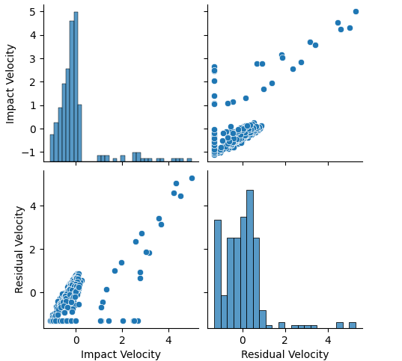

**Fig. Relation in Impact Velocity and Residual Velocity**

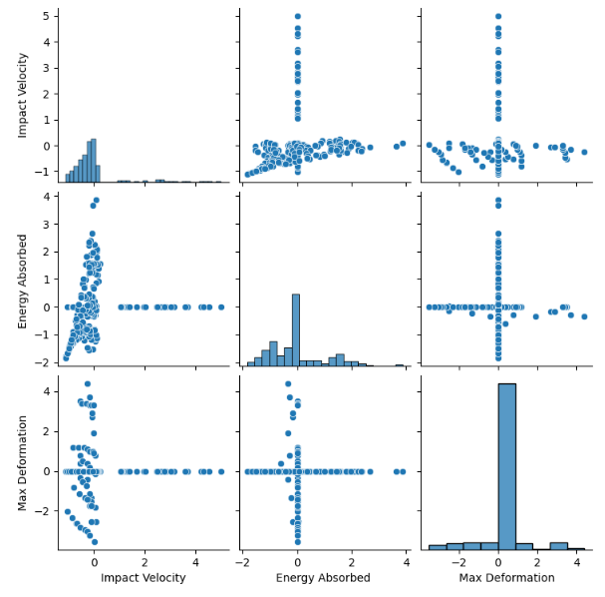

**Fig. Relationships in Max Deformation, Energy Absorbed and Impact Velocity**

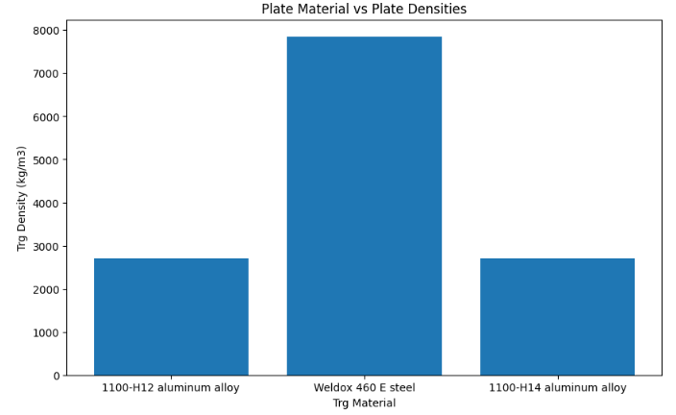

**Fig. Plate Materials and their Densities**

**5.6 Predictions**

**Problem 7 : Predicting the Residual Velocity of Projectiles after impact with target plates.**

* **Dataset : “Impact Velocity Dataset”**
* Test-Train Split : 20-80
* First we have dropped columns = ["Sno.","Energy Absorbed ","Max Deformation","From Reference","Residual Velocity","Velocity Drop"]
* Encoding of categorical_cols ['Trg Material', 'Prj Material',"Shape of Prj"] has been performed with OneHotEncoder.
* The data has also been scaled through module StandardScaler.

| **Model** | **Mean Squared Error** | **Mean Absolute Error** | **R² Score** | **Hyperparameters** |
| --- | --- | --- | --- | --- |
| **Support Vector Regressor** | 1885.843 | 28.899 | 0.101 | Default |
| **Light Gradient Boost** | 897.907 | 15.303 | 0.572 | Default |
| **Ridge** | 471.5115 | 14.2615 | 0.7753 | alpha: 1.0 |
| **Lasso** | 468.7097 | 12.8205 | 0.7766 | alpha: 0.1 |
| **Elastic Net** | 457.274 | 12.9803 | 0.7821 | alpha: 0.09, l1_ratio: 0.99 |
| **Linear Regression** | 452.369 | 12.568 | 0.784 | Default |
| **Random Forest Regressor** | 407.895 | 12.117 | 0.806 | n_estimators=100 |
| **Extreme Gradient Boost** | 358.383 | 10.161 | 0.829 | Default |
| **Neural Network** | 338.8008 | 10.1853 | 0.8385 | layers: [64, 64, 1], activation: 'relu', optimizer: 'adam', loss: 'mean_squared_error', epochs: 100, batch_size: 7 |
| **Kernel Ridge (Laplacian)** | 114.8579 | 7.0009 | 0.9453 | alpha: 0.001, kernel: 'laplacian' |

**Problem 8 : Classifying the tests where Projectiles have caused full penetration of the target plates.**

* **Dataset : “Impact Velocity Dataset”**
* Test-Train Split : 20-80
* First we have dropped columns = ["Sno.","Energy Absorbed ","Max Deformation","From Reference","Residual Velocity","Velocity Drop"]
* Encoding of categorical_cols ['Trg Material', 'Prj Material',"Shape of Prj"] has been performed with OneHotEncoder.
* The data has also been scaled through module StandardScaler.
* A new binary variable y has been created with value (0 or 1) based on if the residual velocity is 0 or anything, Any residual velocity other than 0 means full penetration.

| **Classifier** | **Accuracy** | **Precision** | **Recall** | **F1 Score** | **AUC** | **Hyper Parameters** |
| --- | --- | --- | --- | --- | --- | --- |
| **Decision Tree**  **Classifier** | 0.833 | 0.872 | 0.833 | 0.852 | 0.444 | Default |
| **Random Forest**  **Classifier** | 0.875 | 0.875 | 0.875 | 0.875 | 0.467 | Default |
| **SVC** | 0.896 | 0.876 | 0.896 | 0.886 | 0.478 | Default |
| **Gradient Boosting Classifier** | 0.896 | 0.911 | 0.896 | 0.903 | 0.633 | Default |
| **Cat Boost Classifier** | 0.896 | 0.911 | 0.896 | 0.903 | 0.633 | iterations=100, learning_rate=0.1, depth=6 |
| **K Neighbors Classifier** | 0.833 | 0.872 | 0.833 | 0.852 | 0.444 | n_neighbour = 3 |
| **AdaBoost Classifier** | 0.896 | 0.911 | 0.896 | 0.903 | 0.633 | n_estimators=50, learning_rate=1.0 |
| **Logistic Regression** | 0.854 | 0.874 | 0.854 | 0.864 | 0.456 | Default |

**5.7 Feature Importances**

* For Predicting Residual Velocity.
* Model Random Forest (n_estimators=100)
* Dataset : “Impact Velocity Dataset”
* Test-Train Split : 20-80
* First we have dropped columns = ["Sno.","Energy Absorbed ","Max Deformation","From Reference","Residual Velocity","Velocity Drop"]
* Encoding of categorical_cols ['Trg Material', 'Prj Material',"Shape of Prj"] has been performed with OneHotEncoder.
* The data has also been scaled through module StandardScaler.

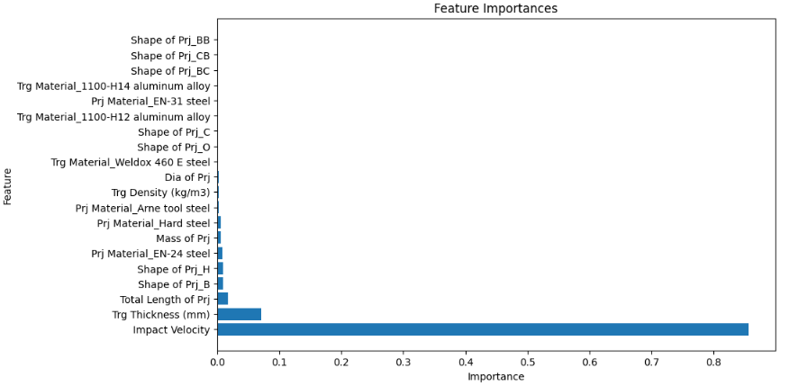

**5.8 Plots of Best Performing Models :**

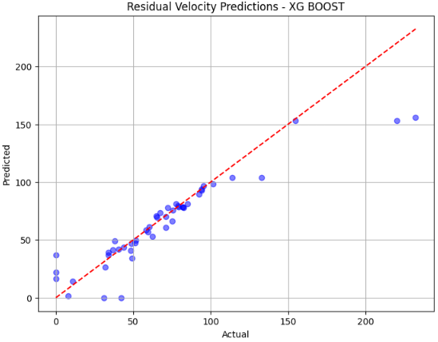

**Fig. Predicting Residual Velocity : XG Boost**

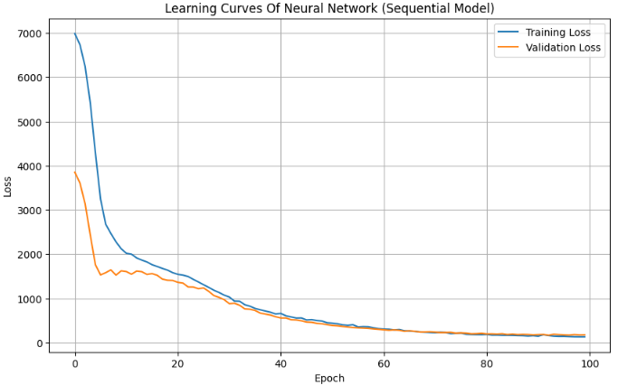

**Fig. Learning Curve : Neural Network**

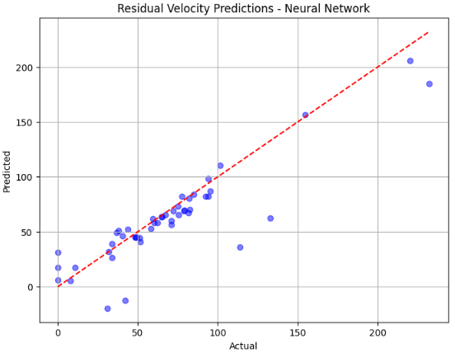

**Fig. Predicted vs Actual Residual Velocity : Neural Network**

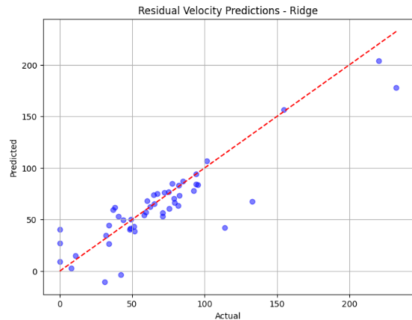

**Fig. Predicted vs Actual Residual Velocity : Ridge**

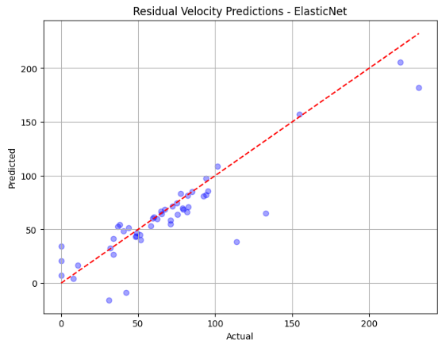

**Fig. Predicted vs Actual Residual Velocity : Elastic Net**

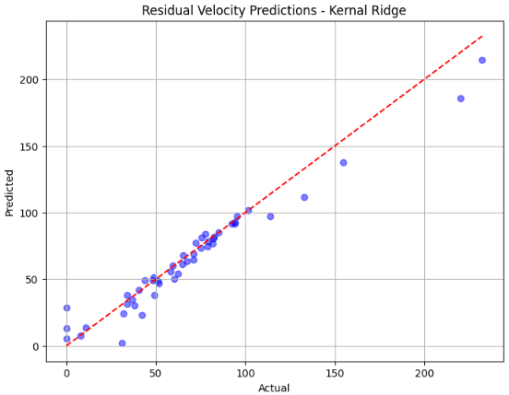

**Fig. Predicted vs Actual Residual Velocity : Kernel Ridge**

**5.9 Best Confusion Metrics Of Problem 8**

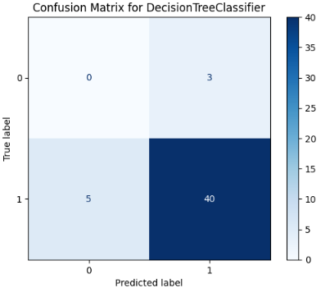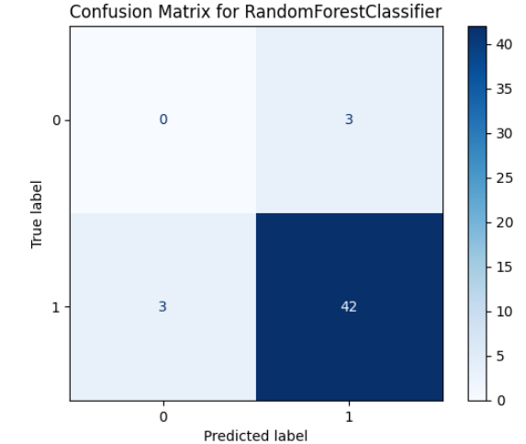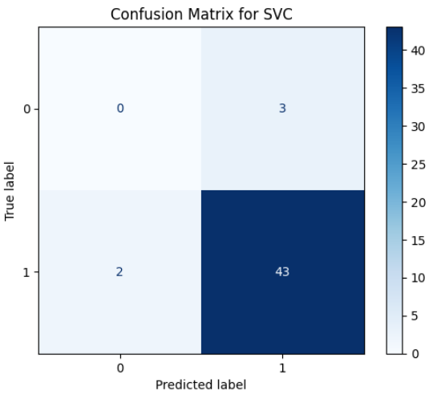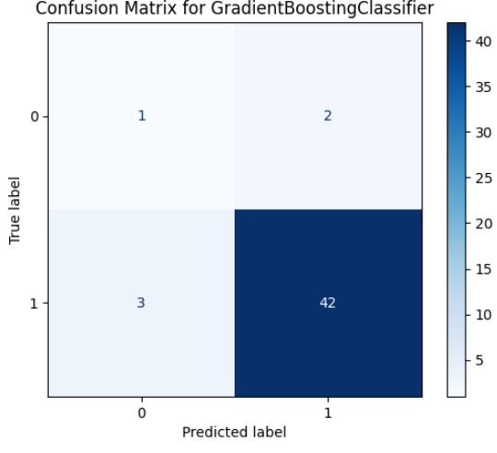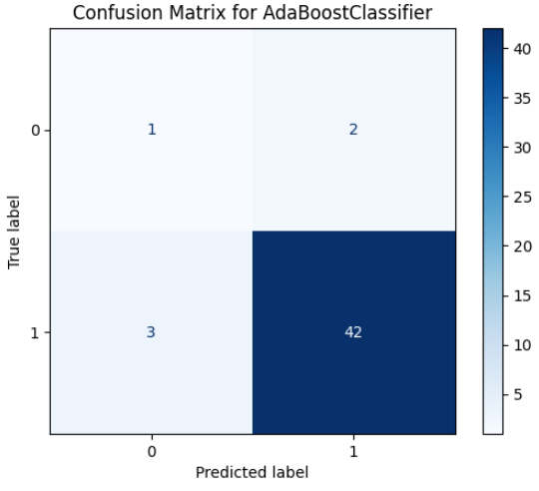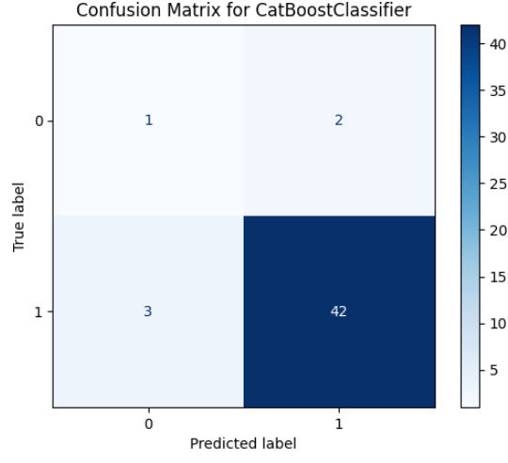

**Chapter 6 : Dataset Gathering Sources :**

**6.1 Impact Velocity Dataset**

1. Perforation of 12 mm thick steel plates by 20 mm diameter projectiles with flat, hemispherical and conical noses Part I: Experimental study
2. Experimental and numerical studies of double-nosed projectile impact on aluminum plates
3. Experimental and numerical studies on the behavior of thin aluminum plates subjected to impact by blunt- and hemispherical-nosed projectiles
4. Effect of projectile nose shape, impact velocity and target thickness on deformation behavior of aluminum plates

**6.2 Anu dataset**

1. PREDICTING HIGH EXPLOSIVE DETONATION VELOCITIES FROM THEIR COMPOSITION AND STRUCTURE
2. Predicting the Detonation Velocity of CHNO Explosives by a Simple Method

**6.3 Renu Dataset**

1. A Simple Method for Calculating the Detonation Pressure of Ideal and Non-Ideal Explosives Containing Aluminum and Ammonium Nitrate
2. Artificial Intelligence Approaches for Energetic Materials by Design: State of the Art, Challenges, and Future Directions

**Conclusion**

In my capacity at DRDO, I am deeply engaged in a pioneering endeavor that merges the cutting-edge capabilities of Machine Learning (ML) with the intricate realm of High-Energy Materials (HEMs). This dynamic fusion allows us to delve into the complexities of HEM properties with unprecedented depth, leveraging ML algorithms to unravel intricate patterns, relationships, and behaviors within these materials. By harnessing the power of data-driven insights, we are not only optimizing synthesis processes and predicting performance characteristics with remarkable accuracy but also accelerating the pace of material design iterations, leading to rapid advancements in HEM research and development.

Additionally, I have applied ML techniques to a projectile dataset, analyzing parameters such as velocity and energy absorption to identify key factors affecting projectile behavior. This work has resulted in predictive models that forecast outcomes like impact force and deformation, enhancing our understanding and optimization of projectile materials.

The impact of this work extends far beyond the confines of our laboratories. It heralds a new era in material science and defense technology, where ML-driven innovations in HEMs are poised to revolutionize multiple sectors. The optimized synthesis processes and predictive models we are developing have the potential to transform the landscape of defense systems, aerospace technologies, energy storage solutions, and beyond. These advancements will not only bolster national security capabilities but also contribute significantly to technological advancements globally.

Furthermore, the integration of ML with HEM research sets the stage for continuous innovation and disruptive breakthroughs in high-performance materials and systems. As we refine our understanding, refine our methods, and unlock new insights at the intersection of ML and HEMs, we are laying the foundation for a future where materials are designed with unparalleled precision, efficiency, and effectiveness. This convergence of expertise and technology promises to shape the trajectory of scientific discovery, engineering excellence, and national defense strategies for years to come.

-------------------------------------------------------------------------------------------------------

**References**

1. X.W. Chen, Q.M. Li, “Perforation of a thick plate by rigid projectiles”, 2003

2. N. Kılıç, S.Bedir, A.Erdik, B.Ekici, A. Taşdemirci, M.Güden, “Ballistic behavior of

high hardness perforated armor plates against 7.62mm armor piercing projectile”, 2014

3. M.A. Iqbal, P.K. Gupta, “Effect of target span and configuration on the ballistic limit” , 2010

4. I.V. Roisman, K. Weber, “Oblique penetration of a rigid projectile into a thick elastic/plastic target: theory and experiment” , 1999

5. T. Deniz, “Penetration of hardened steel plates” , 2010

6. Tore Børvik, “Normal and oblique impact of small arms bullets on AA6082-T4 aluminum protective plates” , 2011

7. N. Kılıç, B. Ekici, “Ballistic resistance of high hardness armor steels against 7.62 mm armor piercing ammunition”, 2012

8. P.K. Jena, N. Jagtap, “Some experimental studies on angle effect in penetration” , 2009

9. Werner Goldsmith, “Non-ideal projectile impact on targets” , 1998

10. Tore Børvik, “Perforation resistance of five different high-strength steel plates subjected small-arms projectiles” , 2008

11. M.A. Iqbal, P.K. Gupta , “3D numerical simulations of sharp nosed projectile impact on ductile targets” , 2009

12. S. Dey, T. Børvik, “The effect of target strength on the perforation of steel plates using three different projectile nose shapes” , 2004

13. Prediction and Construction of Energetic Materials Based on Machine Learning Methods Xiaowei Zang, Xiang Zhou, Haitao Bian, Weiping Jin, Xuhai Pan, Juncheng Jiang M. Yu. Koroleva and Ruiqi Shen

14. Research topics in explosives - a look at explosives behaviors

15. Baker W E 1973 Explosions in Air (Austin: University of Texas Press)

16. Maienschein J L 2012 Propell. Explos. Pyrot. 37 259-260

17. Reaugh J E and Jones A G 2010 Proc. 14th Int. Det. Symp. ONR-351-10-185 909

18. Manaa M R and Fried L E 2012 personal communication

19. 2012 DOE Standard Explosives Safety DOE-STD-1212-201Ma

20. Pagoria P F, Lee G S, Mitchell A R and Schmidt R D 2002 Thermochimica Acta

21. Glascoe E A, Maienschein J L, Lorenz K T, Tan N and Koerner J G 2010 Proc. 14th Int. Det.

22. Hsu P C, Hust G, Howard W M and Maienschein J L 2010 Proc. 14th Int. Det. Symp. ONR-351-10-185 984

23. Lorenz K T 2012 personal communication

24. Burnham A K, Weese R K, Wardell J F, Tran T D, Wemhoff A P, Koerner J G and Maienschein J L 2006 Proc. 13th Int. Det. Symp. ONR-351-07-01 573

25. Maienschein, J L, Wardell J F, Weese R K, Cunningham B J and Tran T D 2002 Proc. 12th Int. Det. Symp. ONR-333-05-2 846

26. National Research Council, Division on Engineering and Physical Sciences. Advanced Energetic Materials (National Academies

Press, 2004).

27. Nielsen, A. T. et al. Synthesis of polyazapolycyclic caged polynitramines. Tetrahedron 54, 11793–11812 (1998).

28. Viswanath, D. S., Ghosh, T. K. & Boddu, V. M. Hexanitrohexaazaisowurtzitane (HNIW, CL-20), 59-100 (Springer Netherlands,

Dordrecht, 2018).

29. Gilmer, J., Schoenholz, S. S., Riley, P. F., Vinyals, O. & Dahl, G. E. Neural message passing for quantum chemistry. arXiv e-prints

1704.01212 (2017).

30. Mannodi-Kanakkithodi, A., Pilania, G., Huan, T. D., Lookman, T. & Ramprasad, R. Machine learning strategy for accelerated design

of polymer dielectrics. Sci. Rep. 6, 20952 (2016).

31. Gomez-Bombarelli, R. et al. Design of efcient molecular organic light-emitting diodes by a high-throughput virtual screening and

experimental approach. Nat. Mat. (2016).

32. Menon, A. et al. Elucidating multi-physics interactions in suspensions for the design of polymeric dispersants: a hierarchical

machine learning approach. Mol. S st. Des. Eng. (2017).

33. Rupp, M., Tkatchenko, A., Muller, K.-R. & von Lilienfeld, O. A. Fast and accurate modeling of molecular atomization energies with

machine learning. Phys. Rev. Lett. 108, 058301 (2012).

34. Yao, K., Herr, J. E., Brown, S. N. & Parkhill, J. Intrinsic bond energies from a bonds-in-molecules neural network. Te J. Phys. Chem.

Lett. 8, 2689–2694 (2017).

35. Pilania, G., Wang, C., Jiang, X., Rajasekaran, S. & Ramprasad, R. Accelerating materials property predictions using machine

learning. Sci. Rep. 3, 2810 (2013).

36. Carande, W. H., Kazakov, A., Muzny, C. & Frenkel, M. Quantitative structure-property relationship predictions of critical properties

and acentric factors for pure compounds. J. Chem. Eng. Data 60, 1377–1387 (2015).

37. Hase, F., Valleau, S., Pyzer-Knapp, E. & Aspuru-Guzik, A. Machine learning exciton dynamics. Chem. Sci. 7, 5139–5147 (2016).

38. Stanev, V. et al. Machine learning modeling of superconducting critical temperature. arXiv e-prints 1709.02727 (2017).

39. Conduit, B., Jones, N., Stone, H. & Conduit, G. Design of a nickel-base superalloy using a neural network. Mater. Des. 131, 358–365

(2017).

40. Faber, F. A., Lindmaa, A., von Lilienfeld, O. A. & Armiento, R. Machine learning energies of 2 million elpasolite (abC2D6) crystals.

Phys. Rev. Lett. 117, 135502 (2016).

41. Schmidt, J. et al. Predicting the thermodynamic stability of solids combining density functional theory and machine learning. Chem.

42. Werner Goldsmith, “Non-ideal projectile impact on targets” , 1998

43. Tore Børvik, “Perforation resistance of five different high-strength steel plates subjected to small-arms projectiles” , 2008

44. M.A. Iqbal, P.K. Gupta , “3D numerical simulations of sharp nosed projectile impact on ductile targets” , 2009

45. S. Dey, T. Børvik, “The effect of target strength on the perforation of steel plates using three different projectile nose shapes” , 2004

46. R. Bobbili, A. Paman, “The effect of impact velocity and target thickness on ballistic performance of layered plates using Taguchi method” , 2013

47. G.Ben-Dor, A. Dubinsky and T. Elperin, “Effect of the order of plates on the ballistic resistance of ductile layered shields perforated by non-conical impactors” , 2006 34

48. S. Dey, T. Børvik, “On the ballistic resistance of double-layered steel plates: An experimental and numerical investigation” , 2007

49. M. Abdel-Kadera, A.Fouda, “Mild steel plates impacted by hard projectiles” , 2014

50. G. Ben-Dor, A. Dubinsky, T. Elperin, “Effect of air gap and order of plates on ballistic resistance of two layered armor” , 1999

51. T. Børvik, M. Langseth, O.S. Hopperstad, K.A. Malo, “Ballistic penetration of steel plates” , 1999

52. M.A. Iqbal, G. Gupta, A. Diwakar, N.K. Gupta, “Effect of projectile nose shape on the ballistic resistance of ductile targets” , 2010

53. M.A. Iqbala, A. Diwakar, A. Rajput, N.K. Gupta, “Influence of projectile shape and incidence angle on the ballistic limit and failure mechanism of thick steel plates” , 2013

54. H.C. Chen, Y.L. Chen, B.C. Shen, “Ballistic resistance analysis of double-layered composite material structures , 2013

55. B Ramakrishna, “Numerical studies on perforation of multi-layered targets by hemispherical- nosed projectiles” , 2014

56. X. Teng, T. Wierzbicki, M. Huang, “Ballistic resistance of double-layered armor plates” , 2008

57. A. Manes, F. Serpellini, M. Pagani, M. Saponara, M. Giglio, “Perforation and penetration of aluminum target plates by armour piercing bullets” , 2014

58. E.A. Flores-Johnson, M. Saleh, L. Edwards, “Ballistic performance of multi-layered metallic plates impacted by a 7.62-mm APM2 projectile” , 2011

59. A. Tate, “A simple estimate of the minimum target obliquity required for the ricochet of a high speed long rod projectile”, 1979

**Appendix**

To set up your Python environment with the necessary libraries for machine learning and data visualization, follow the instructions below.

* + - 1. **Installing Python**

**1. Download Python:**

- Go to the official Python website: [python.org](https://www.python.org/downloads/)

- Download the latest version of Python for your operating system.

**2. Install Python:**

- Run the downloaded installer.

- Make sure to check the option "Add Python to PATH" during installation.

- Follow the on-screen instructions to complete the installation.

* + - 1. **Jupyter Notebook**

**1. Install pip (if not already installed):**

- Pip is the package installer for Python. It is usually installed by default with Python.

- Verify pip installation by typing the following command:

pip --version

- If pip is not installed, you can download it from [get-pip.py](https://bootstrap.pypa.io/get-pip.py) and run the script:

python get-pip.py

**2. Install Jupyter Notebook:**

- Open a command prompt or terminal.

- Type the following command and press Enter:

pip install jupyter

**3. Verify Jupyter Notebook Installation:**

- To ensure Jupyter Notebook is installed correctly, type the following command:

jupyter --version

**4. Launch Jupyter Notebook:**

- In the command prompt or terminal, type the following command and press Enter:

jupyter notebook

- This will open the Jupyter Notebook interface in your default web browser.

.

* + - 1. **Virtual Environment Setup**

**1. Create a virtual environment:**

python -m venv myenv

**2. Activate the virtual environment:**

**- On Windows:**

myenv\Scripts\activate

**- On macOS/Linux:**

source myenv/bin/activate

* + - 1. **Installing Required Libraries**

**3. Install TensorFlow:**

pip install tensorflow

**4. Install Matplotlib:**

pip install matplotlib

**5. Install Seaborn:**

pip install seaborn

**6. Install Scikit-learn:**

pip install scikit-learn

**7. Install Keras:**

pip install keras

**8. Install XGBoost:**

pip install xgboost

**9. Install LightGBM:**

pip install lightgbm

* + - 1. **Verifying Installations**

To verify the installations, run the following Python script:

**```python**

**import tensorflow as tf**

**import matplotlib.pyplot as plt**

**import seaborn as sns**

**from sklearn import datasets**

**import keras**

**import xgboost as xgb**

**import lightgbm as lgb**

**print("TensorFlow version:", tf.__version__)**

**print("Matplotlib version:", plt.__version__)**

**print("Seaborn version:", sns.__version__)**

**print("Scikit-learn version:", datasets.__version__)**

**print("Keras version:", keras.__version__)**

**print("XGBoost version:", xgb.__version__)**

**print("LightGBM version:", lgb.__version__)**

**```**

If all libraries are installed correctly, this script will print the version numbers of each library.